Mongo DB

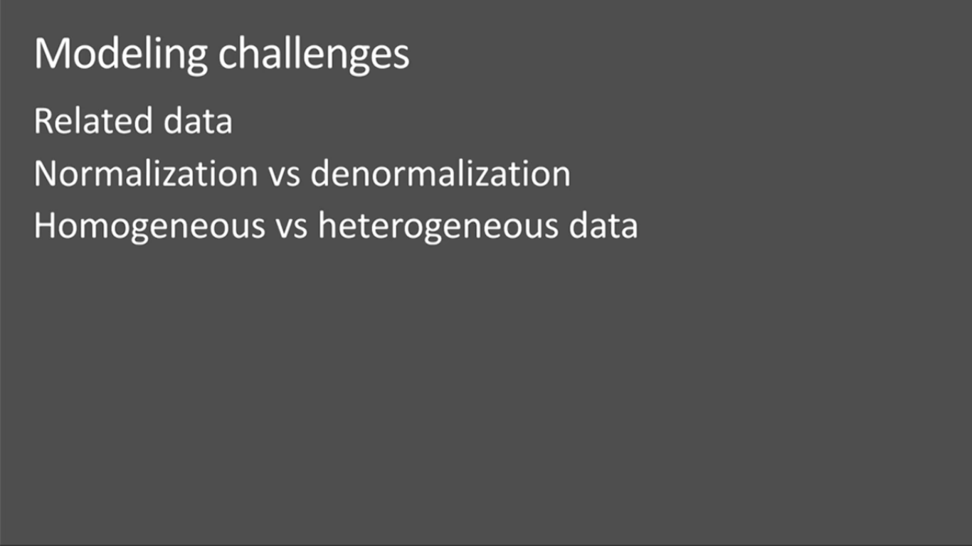

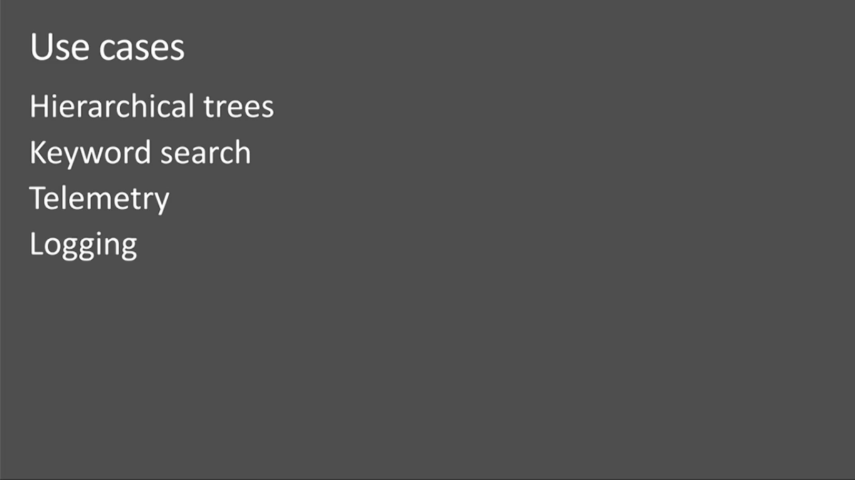

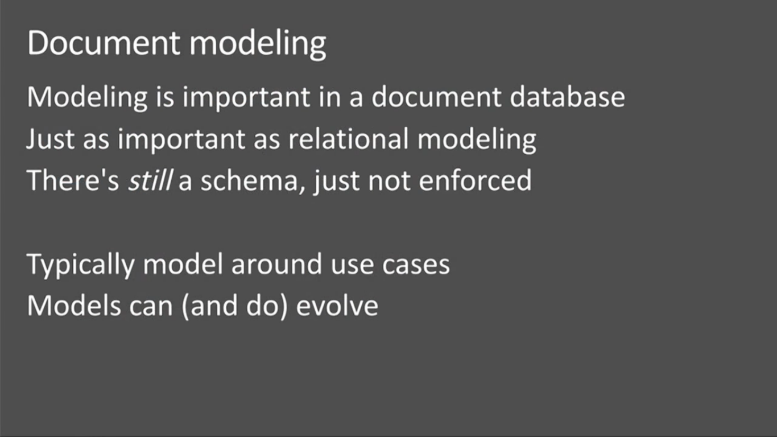

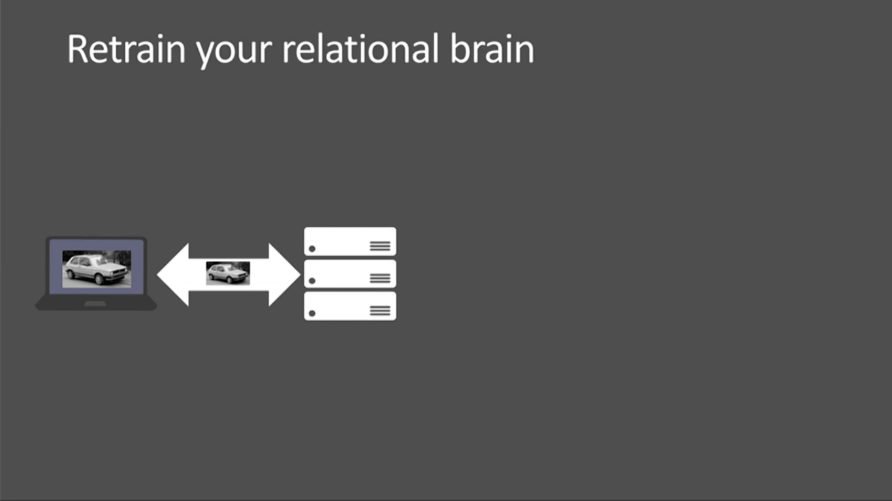

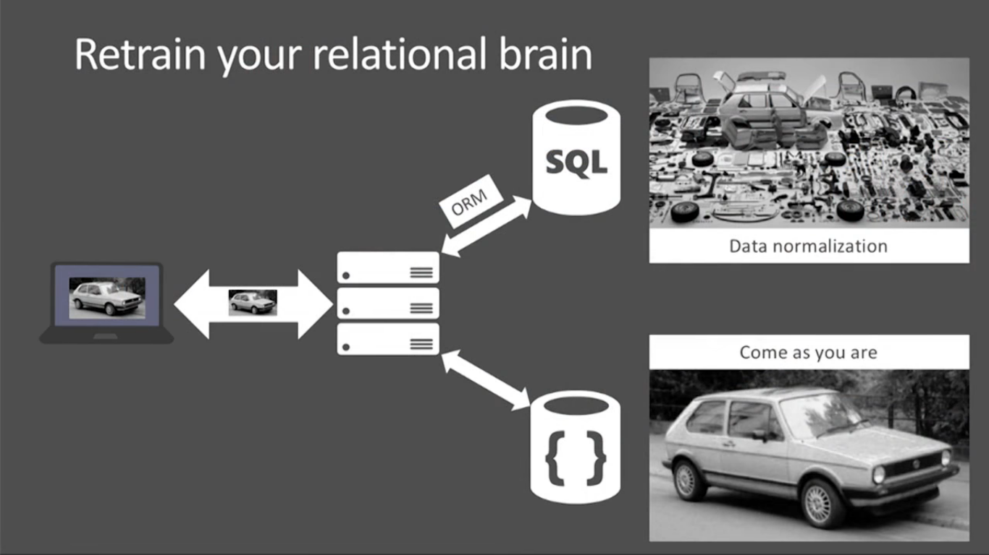

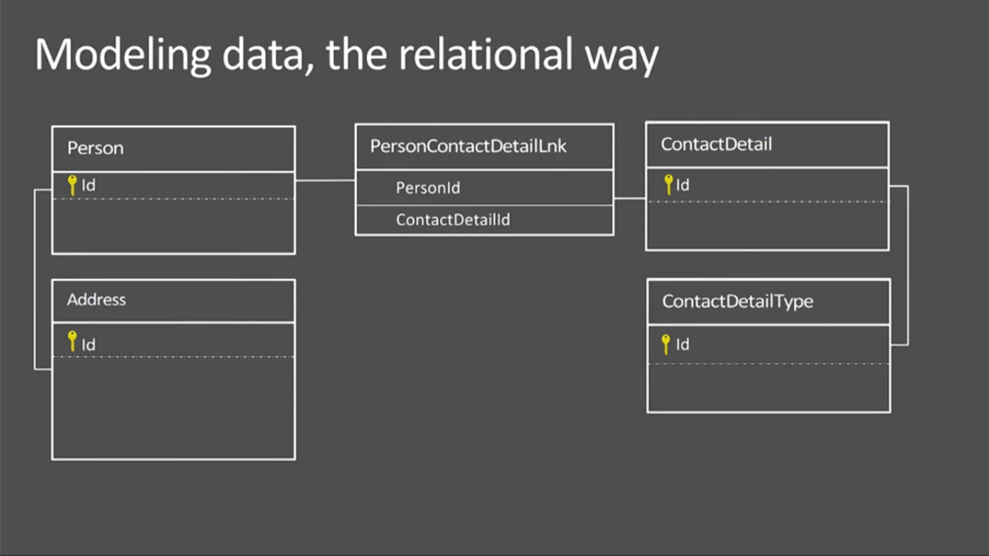

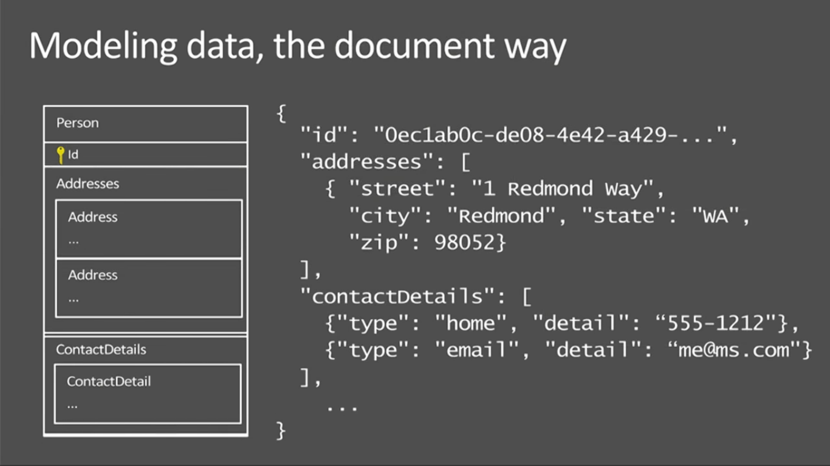

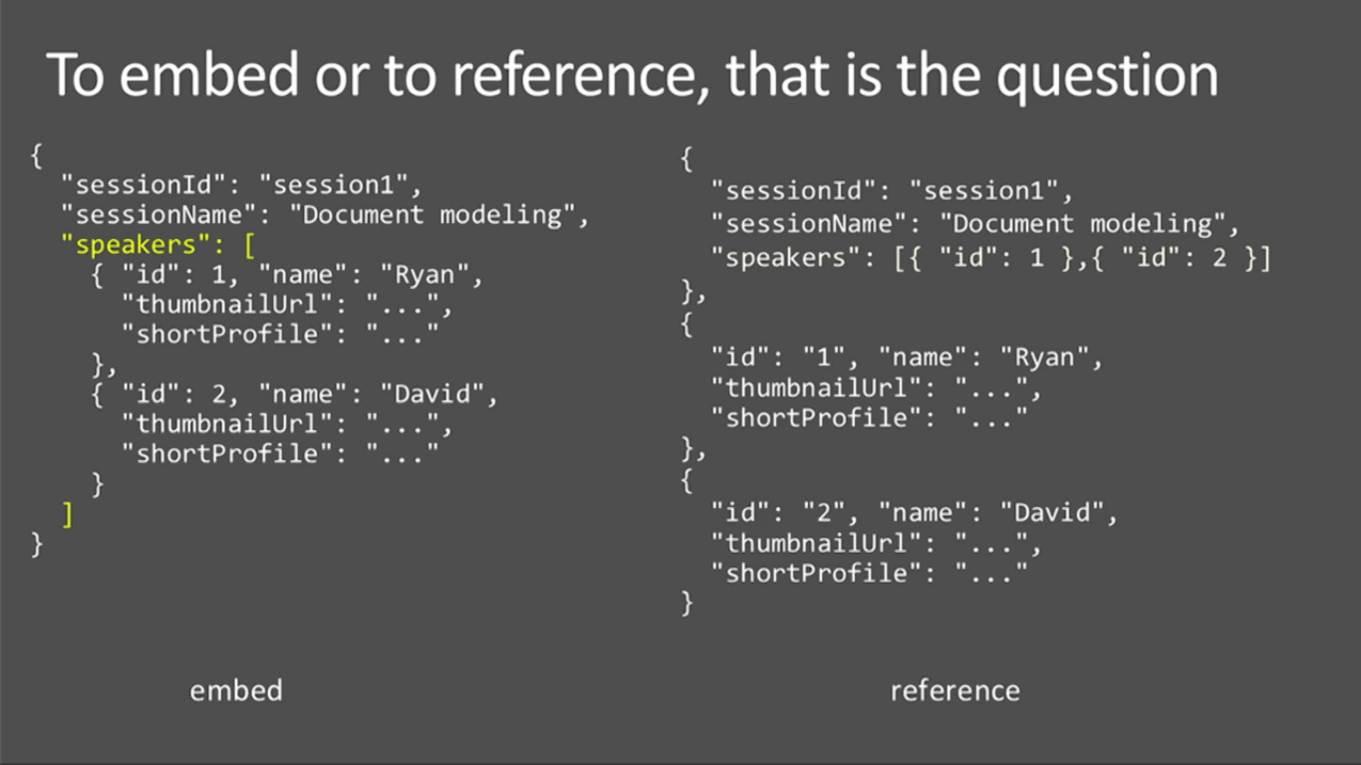

Bad:

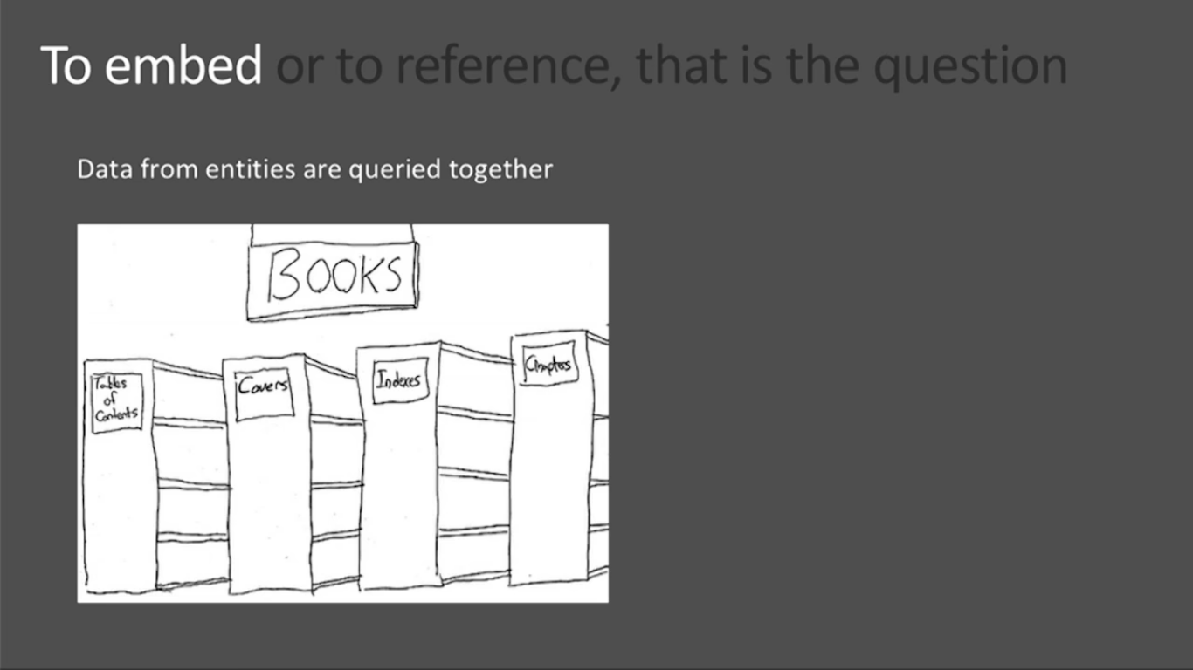

Good:

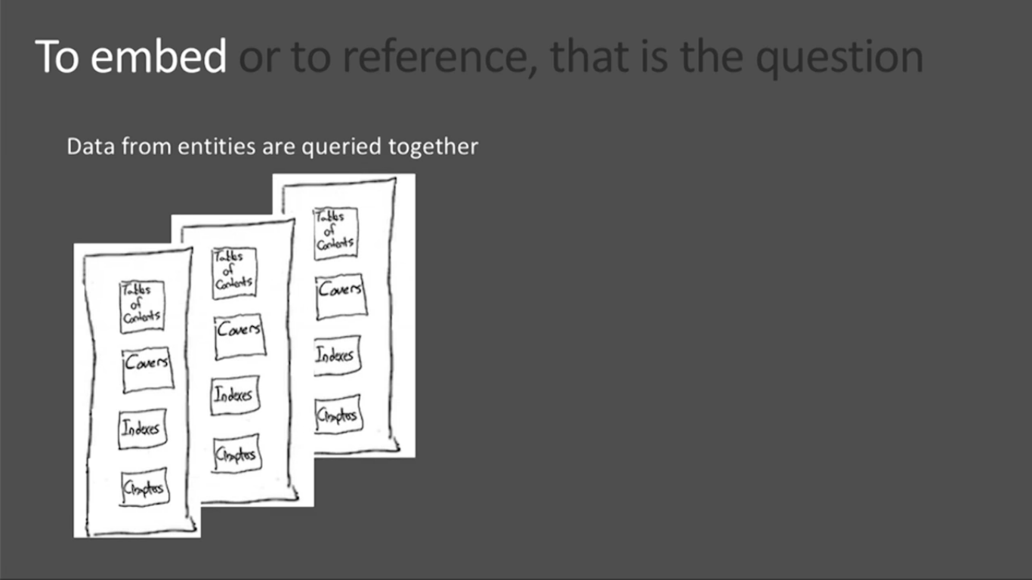

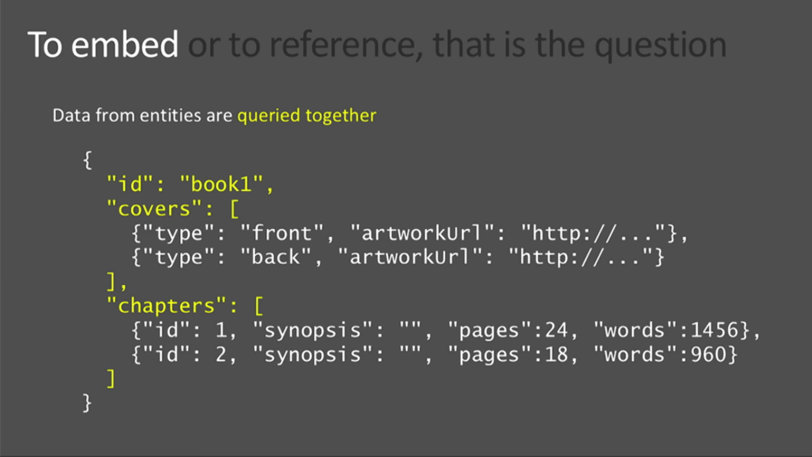

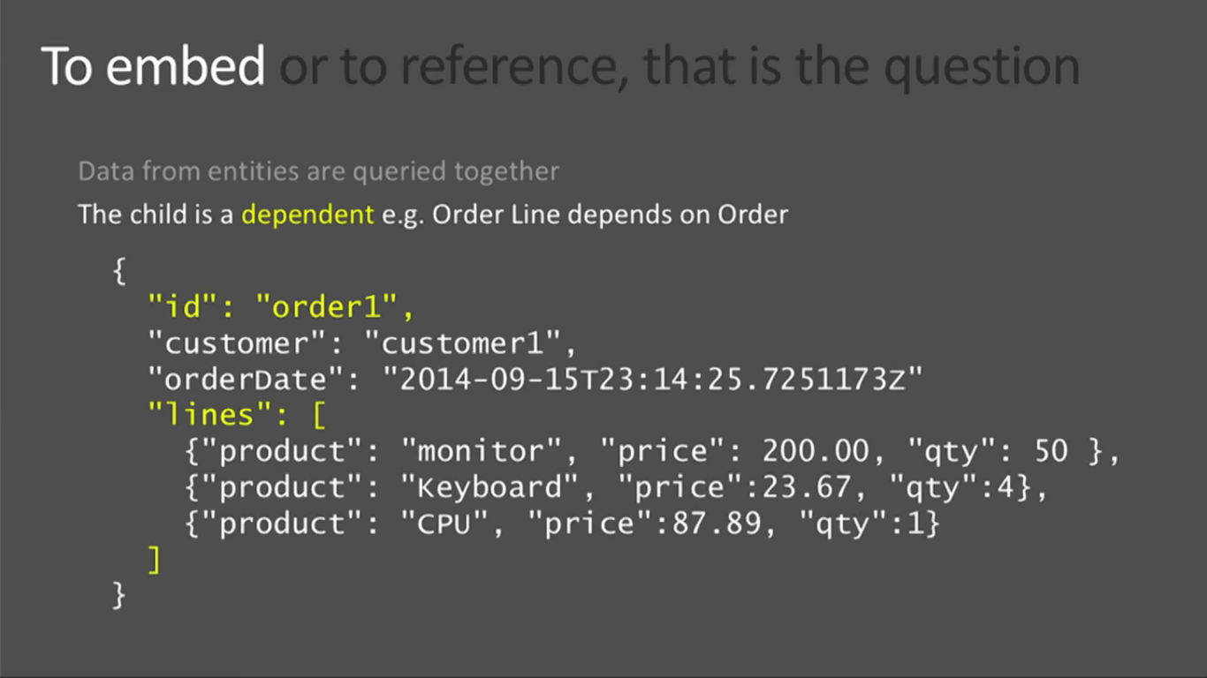

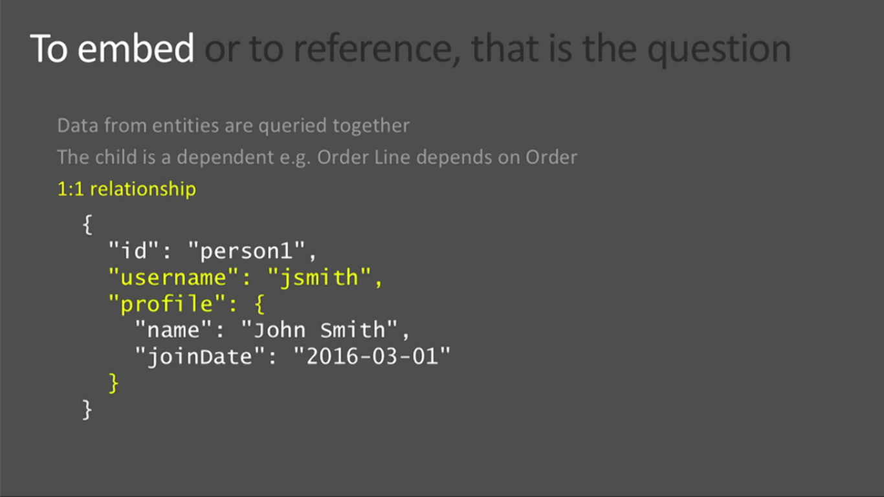

Not frequently a person changing the mail id and social id’s. So, can group together.

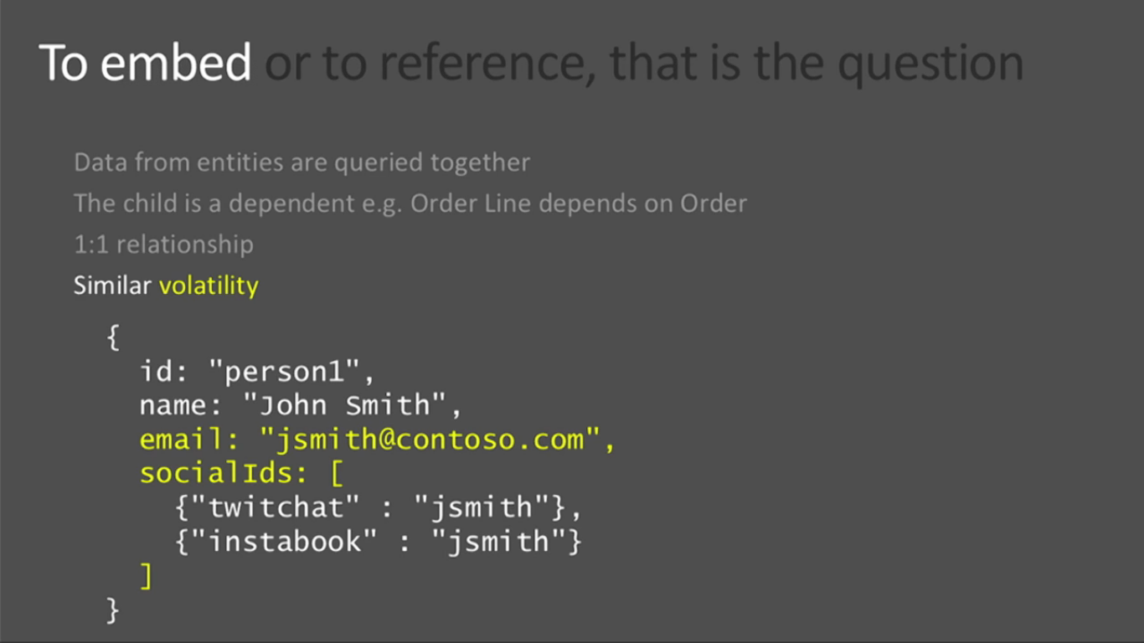

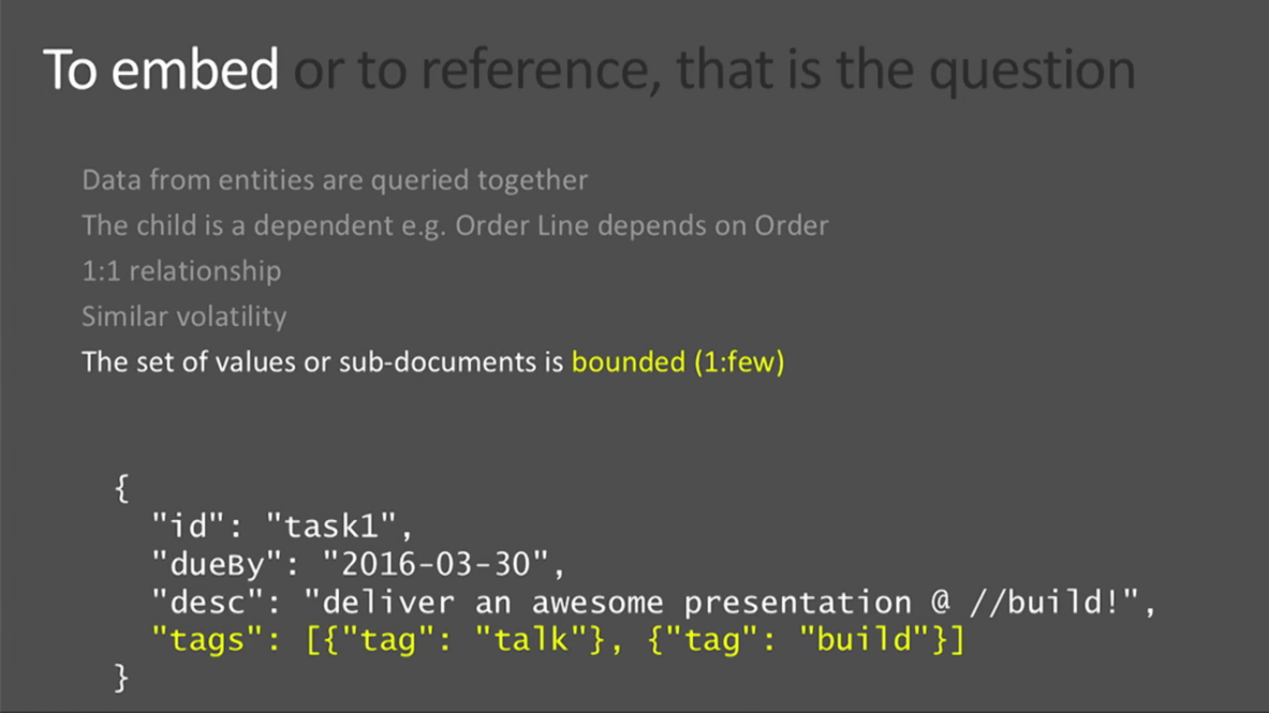

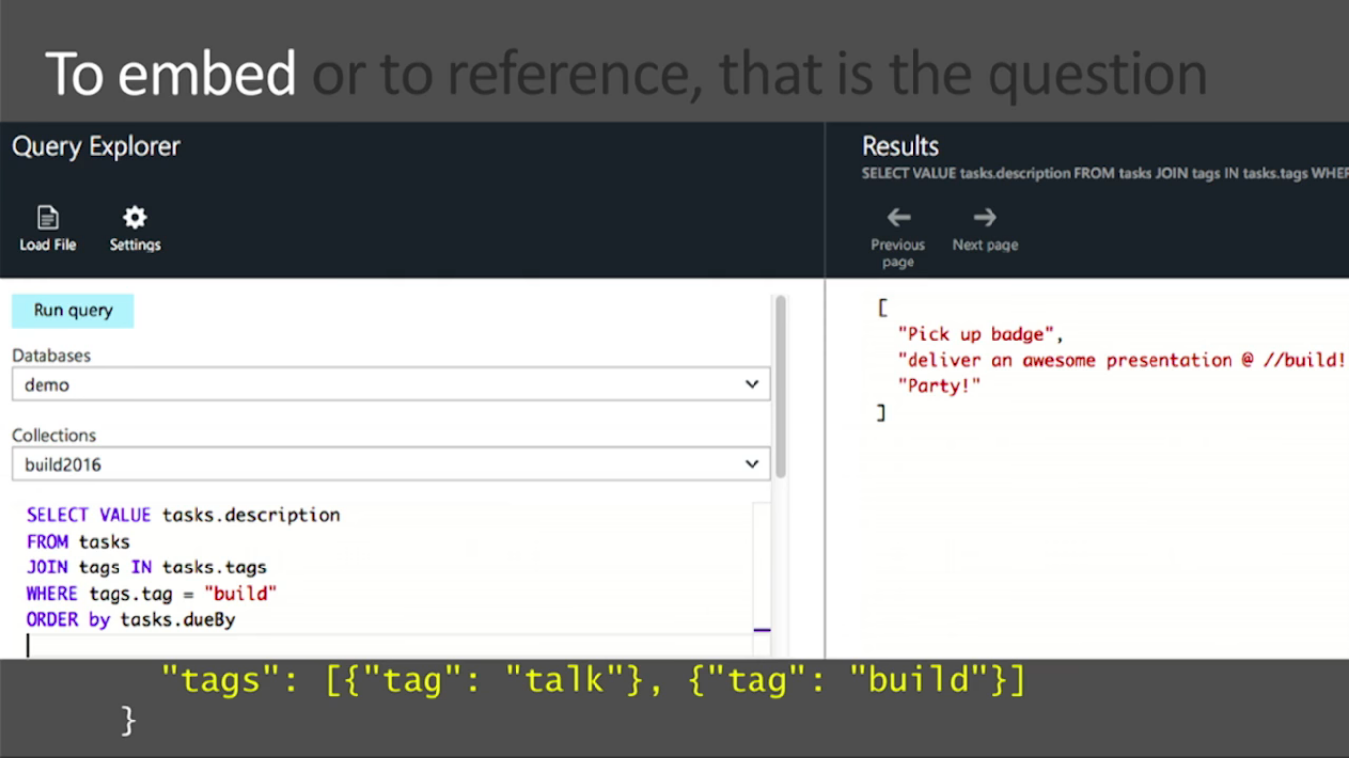

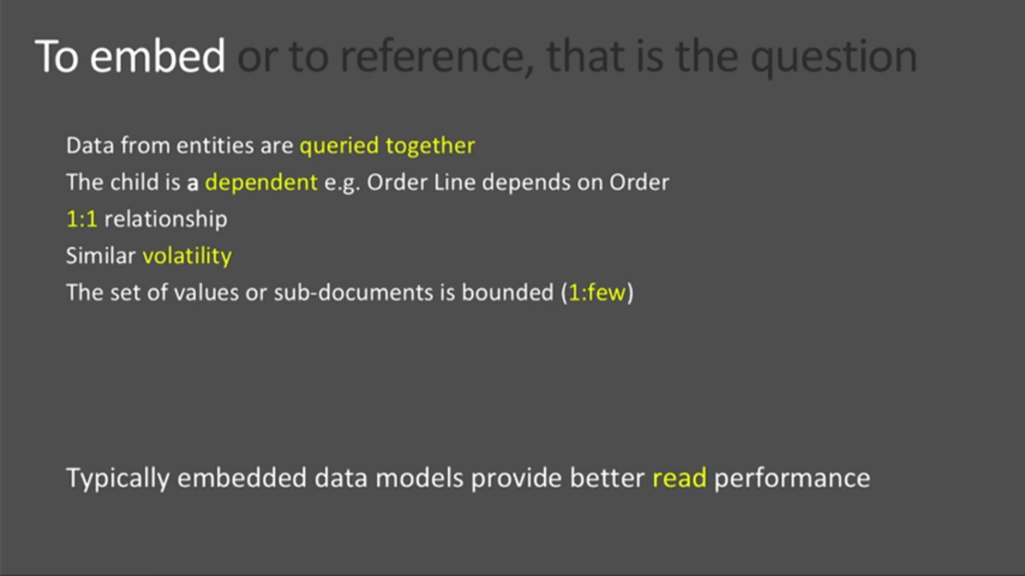

When we have lot of comments (can’t predict the numbers) then it is difficult to manage in embedded way. Performance will be slower when it continuously grows.

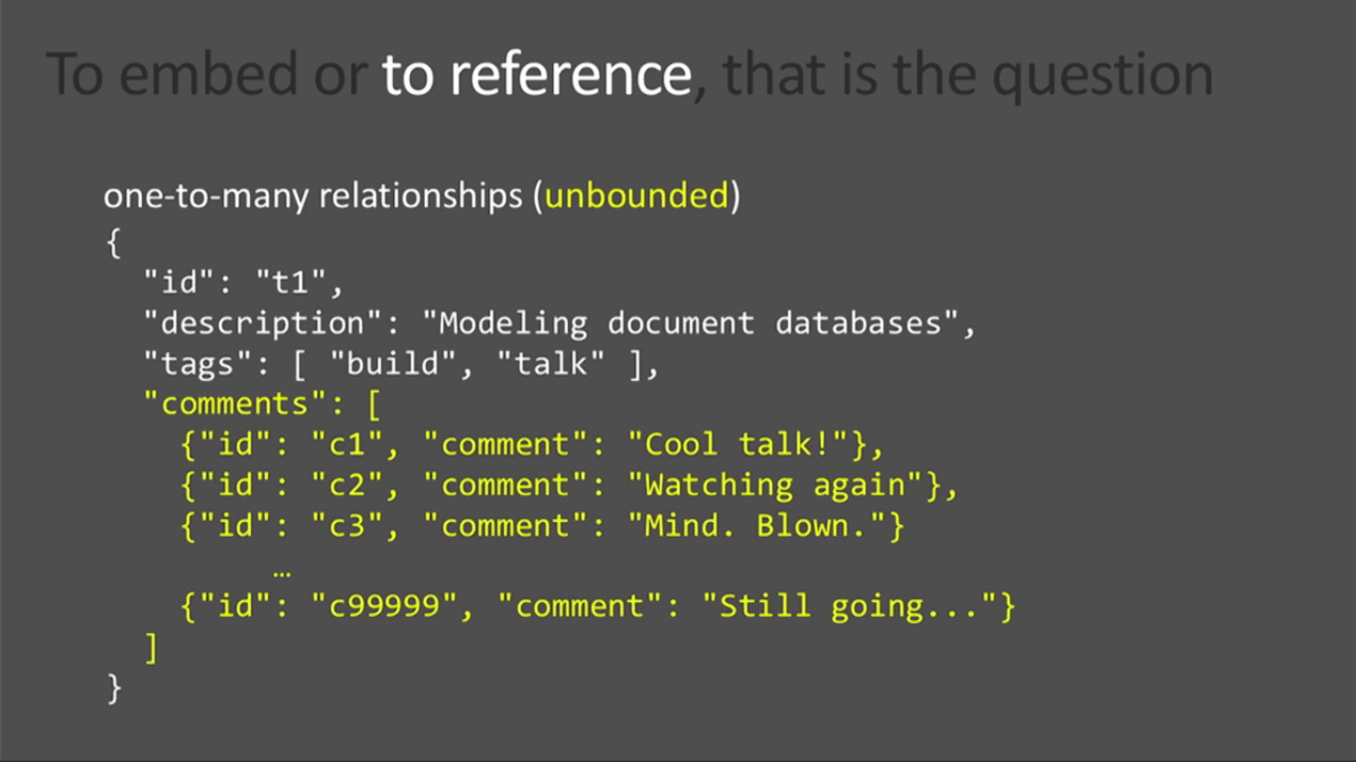

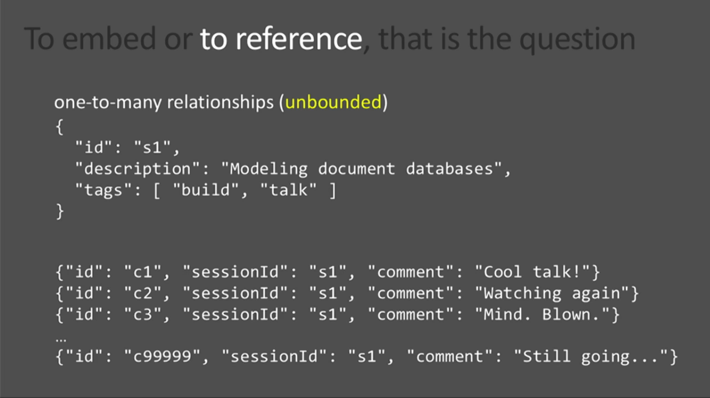

Many-to-many relation way:

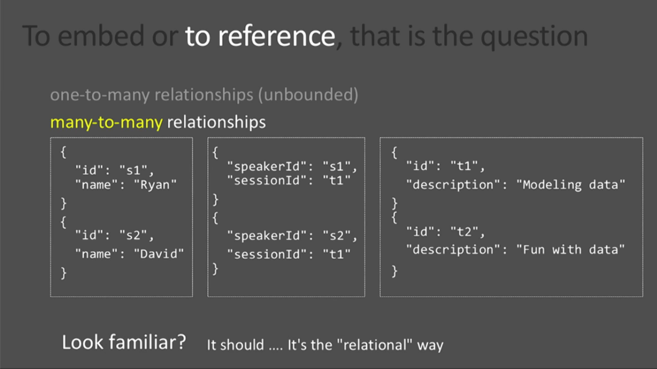

Make it better / Document way:

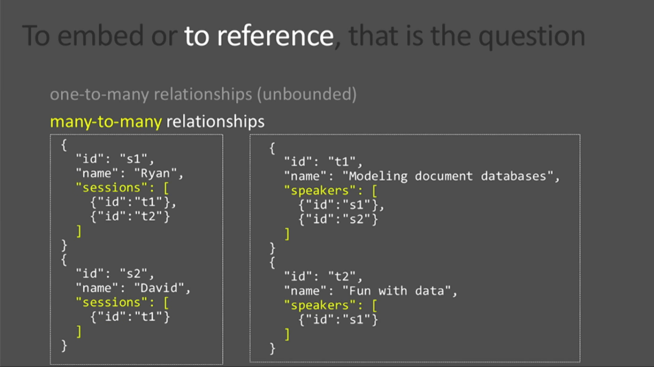

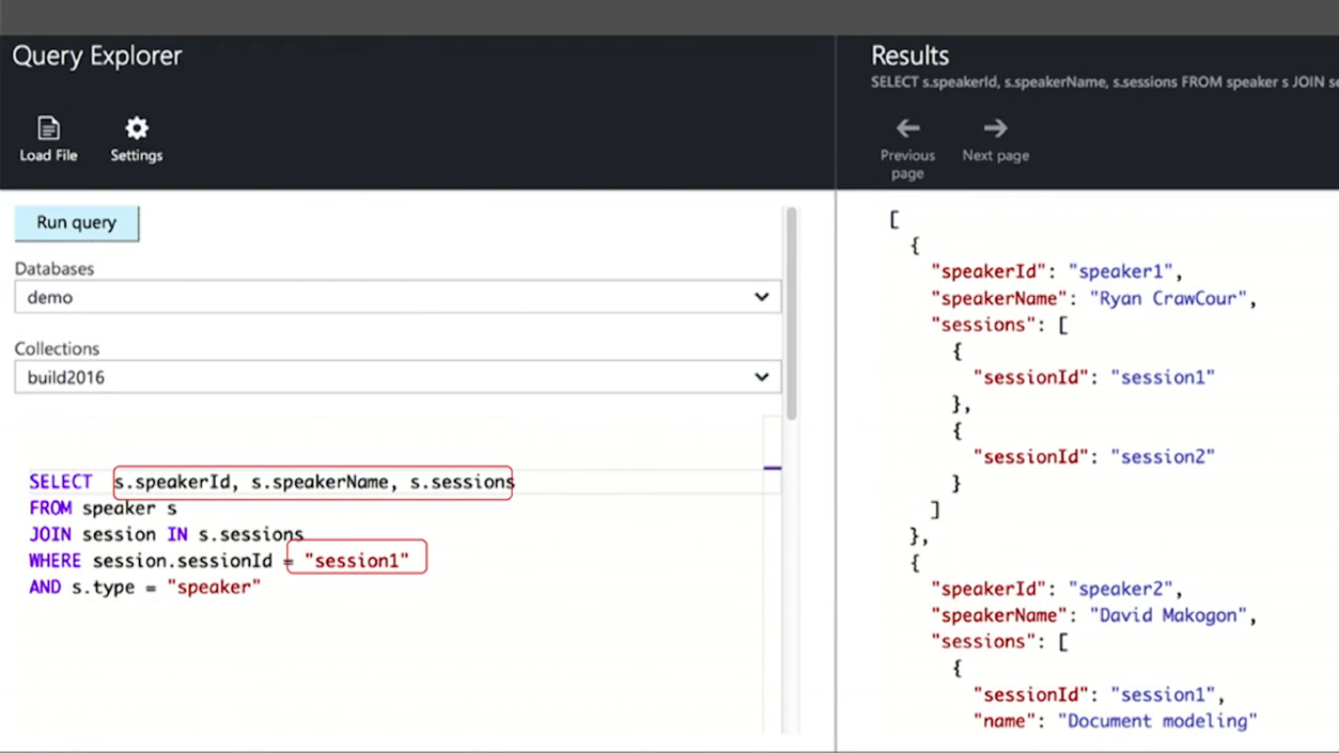

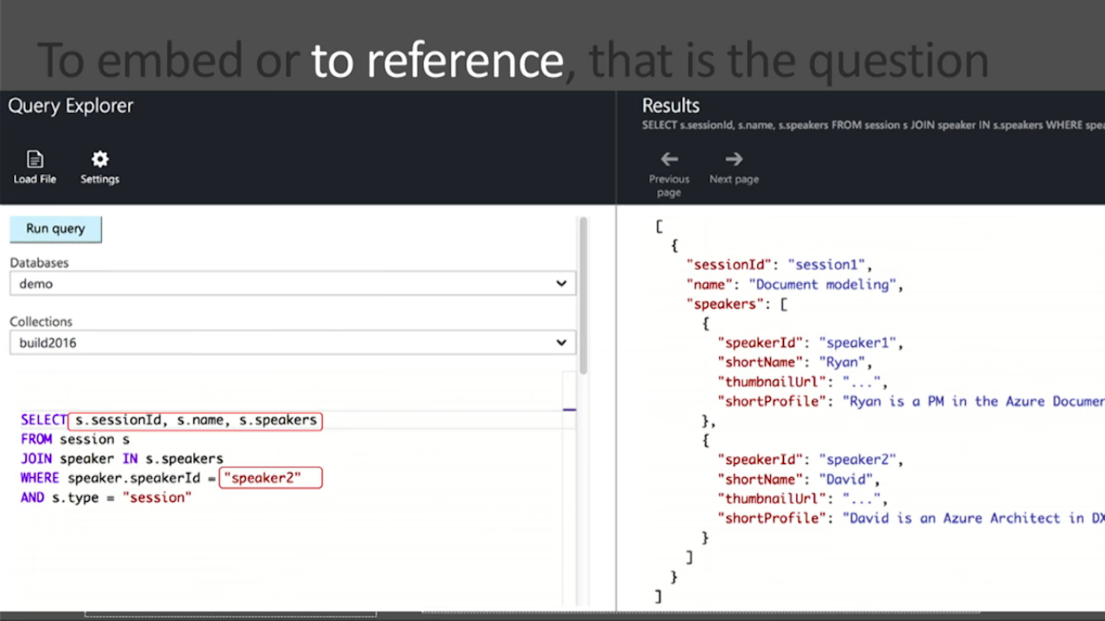

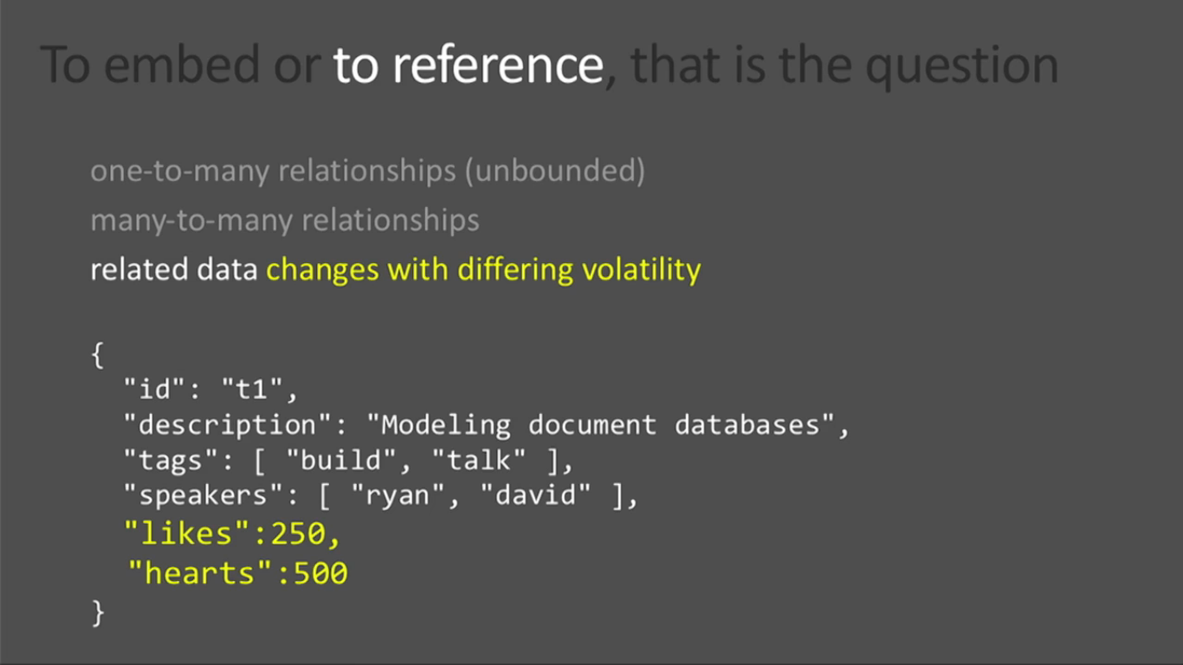

Likes / hearts / number of comments can be in small different document due to volatility (Unpredictability).

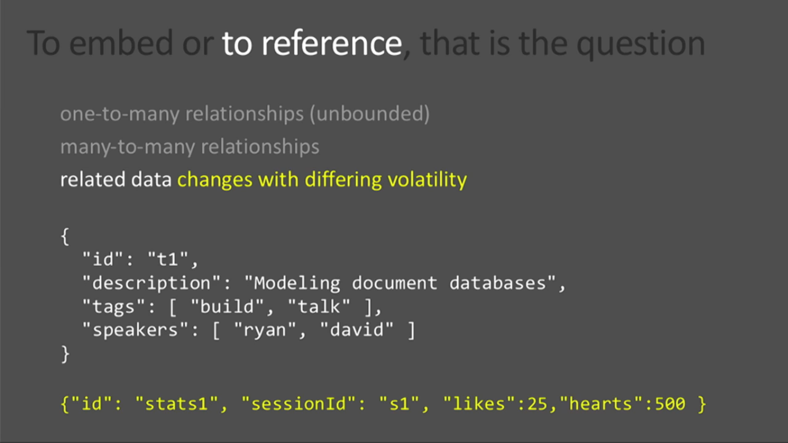

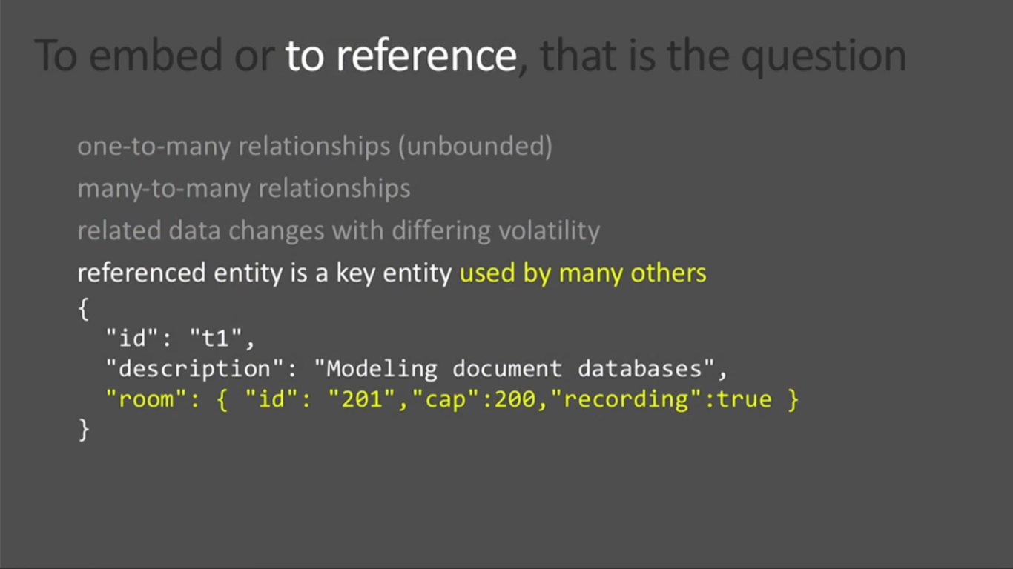

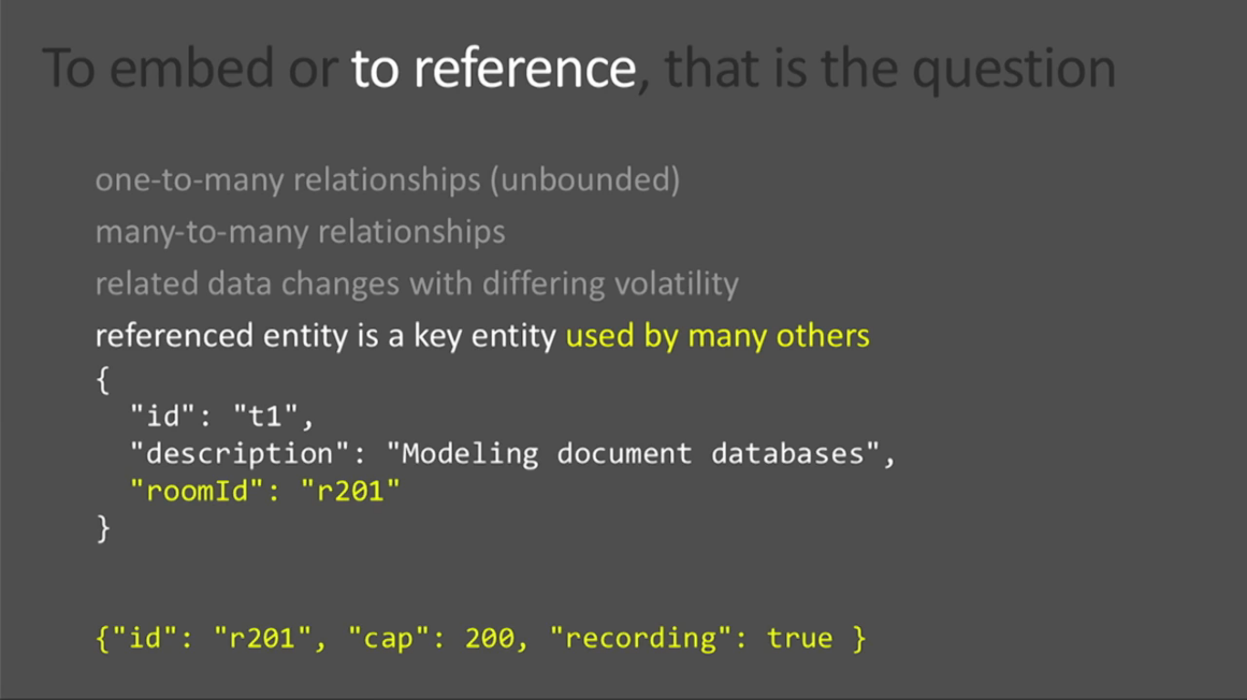

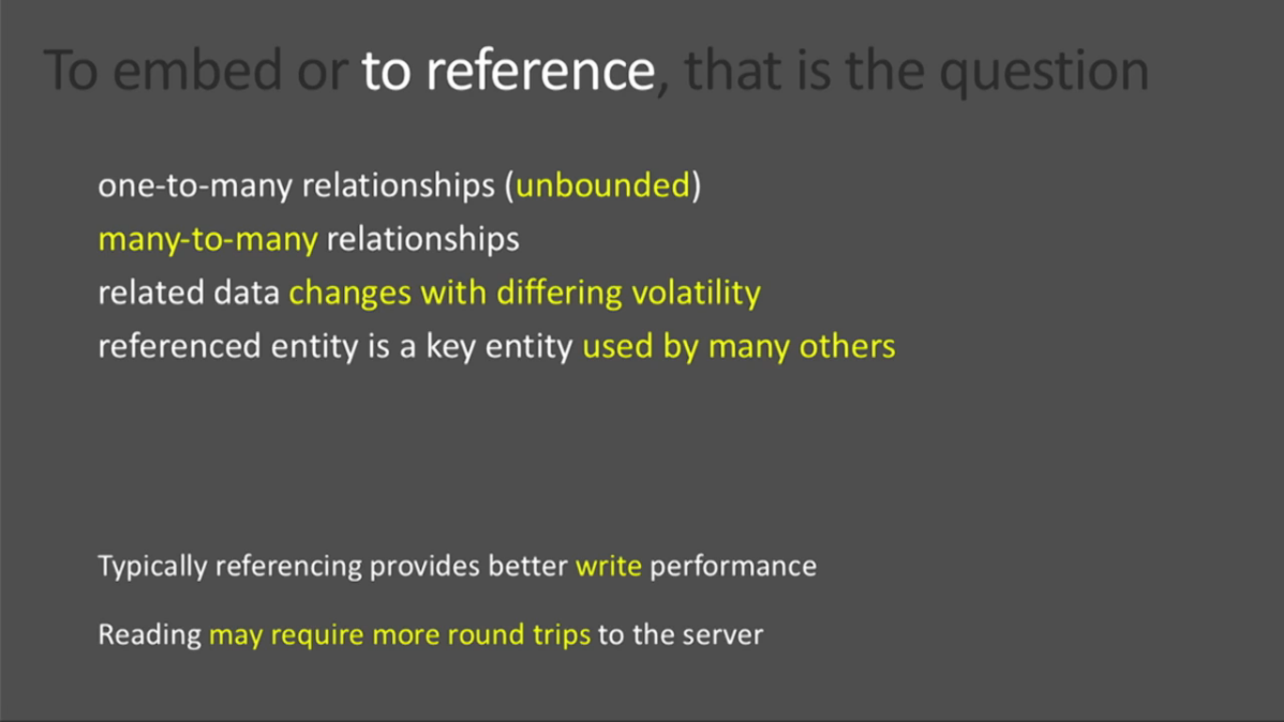

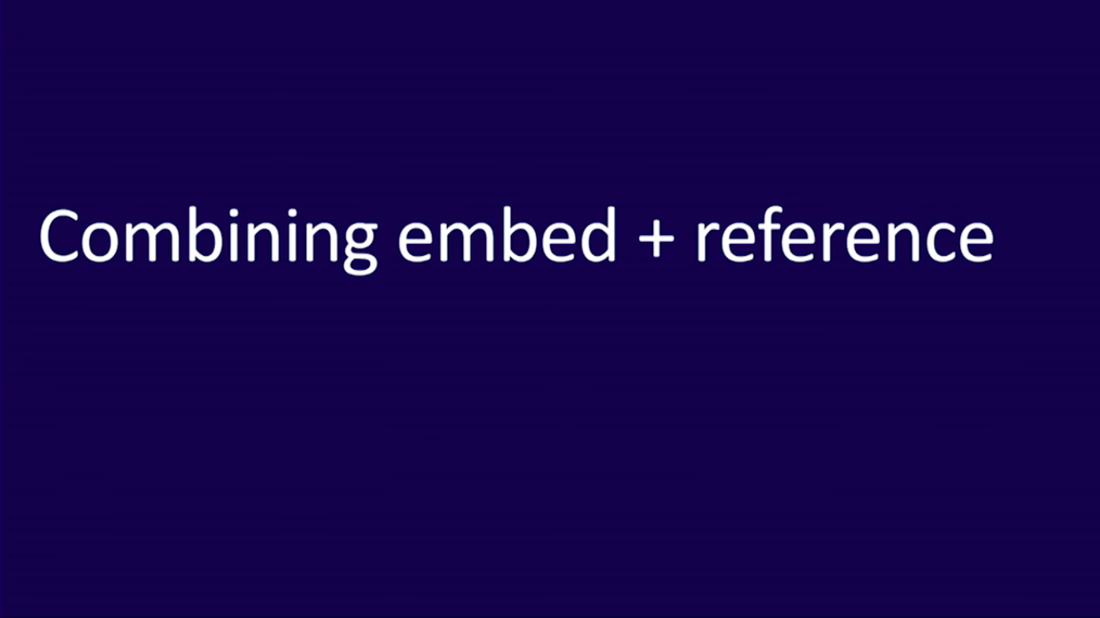

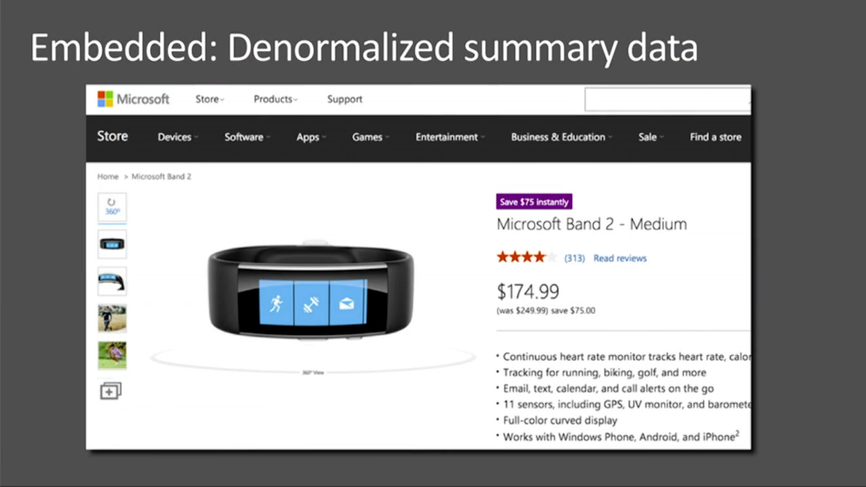

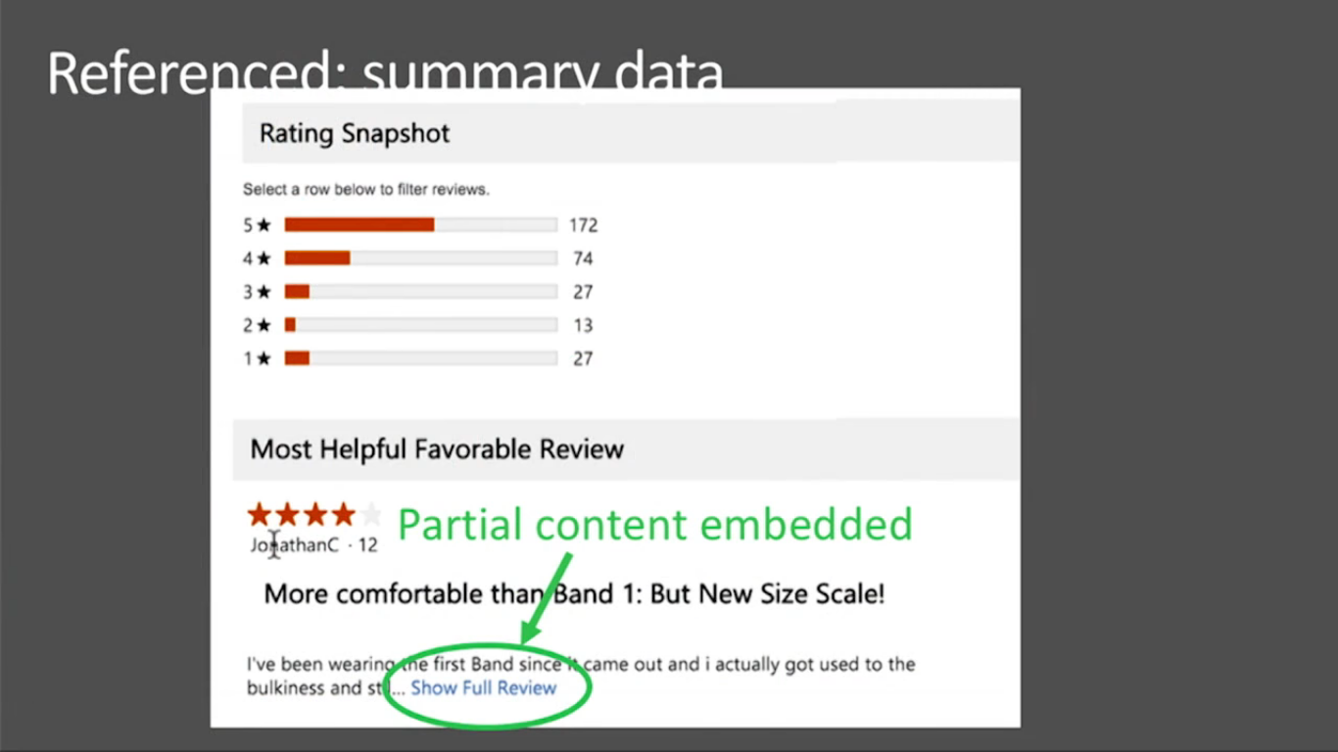

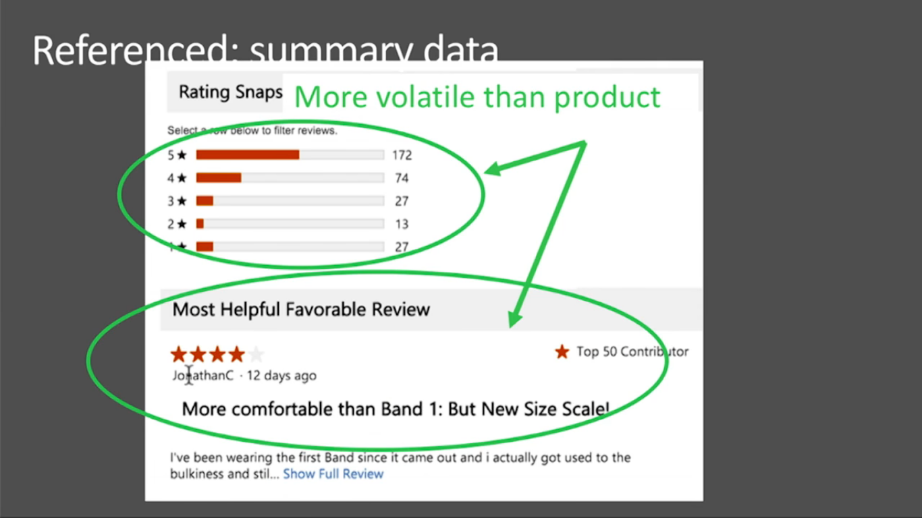

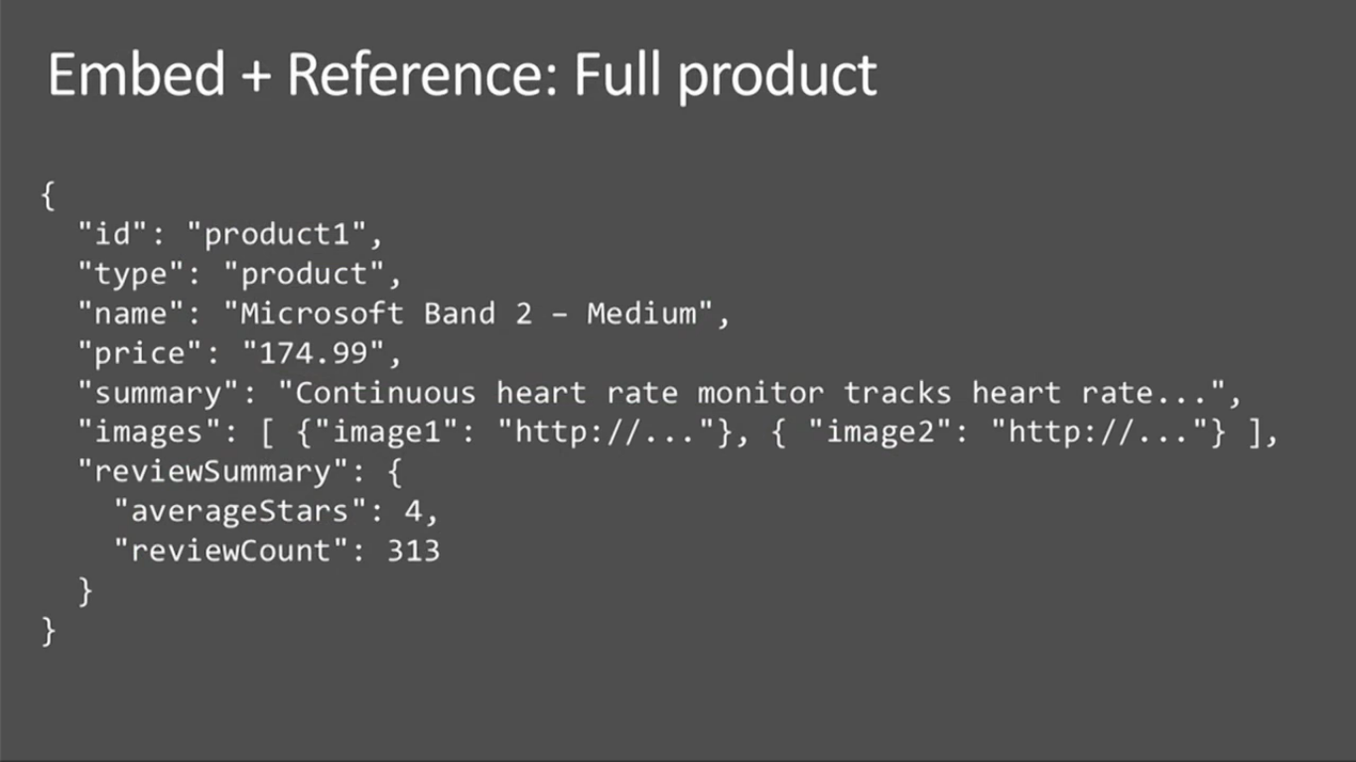

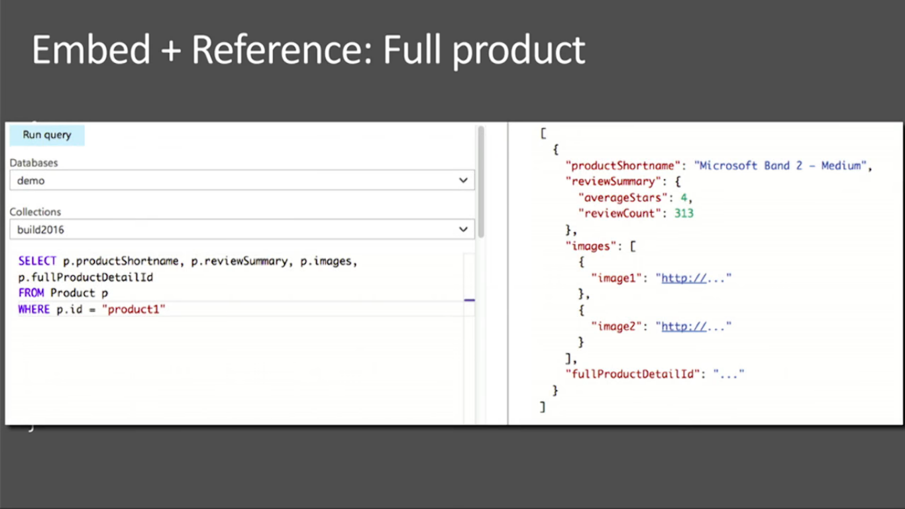

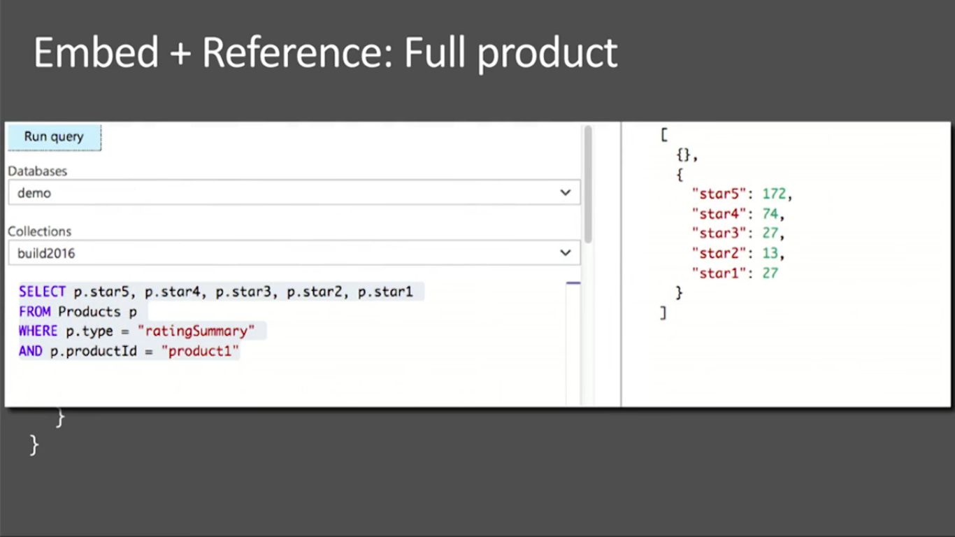

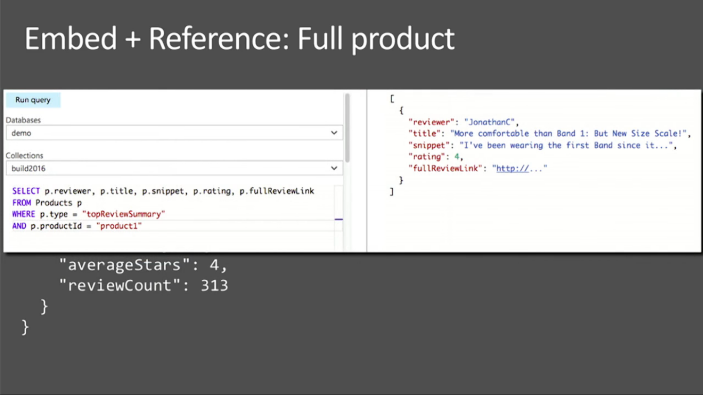

<https://www.youtube.com/watch?v=-o_VGpJP-Q0&pbjreload=10>

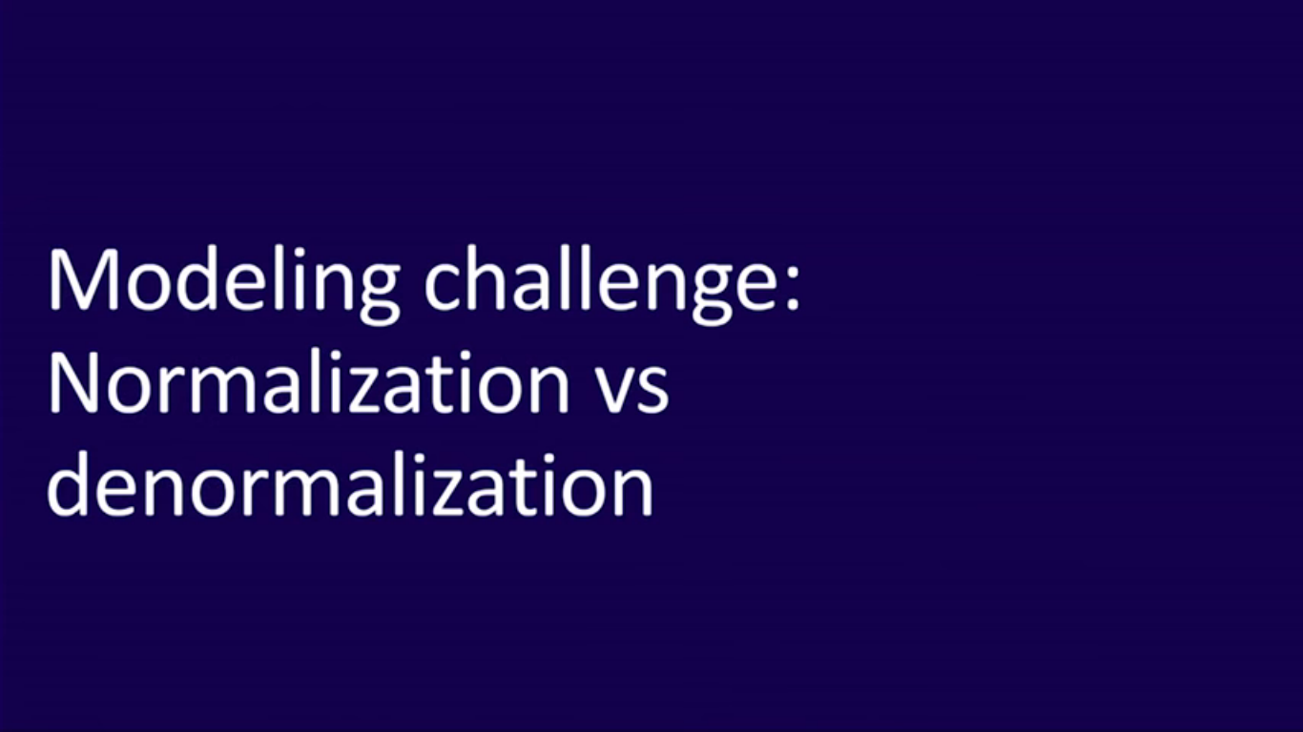

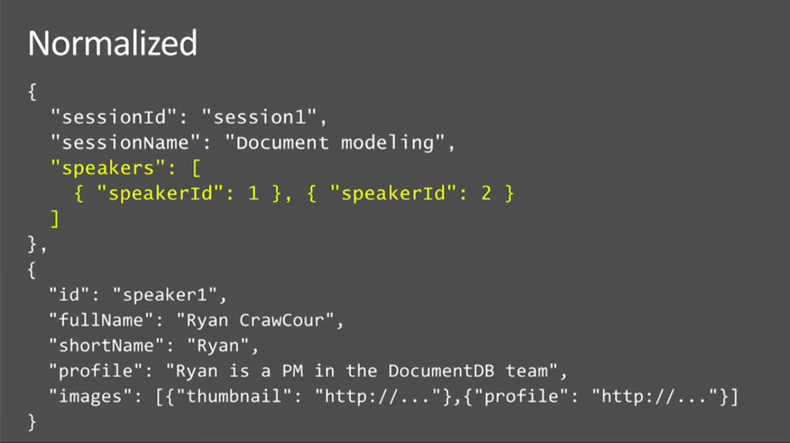

In case I need to show small information about speaker in first page, I will design the DB like below. So that I need not do the double load every time while display the session details.

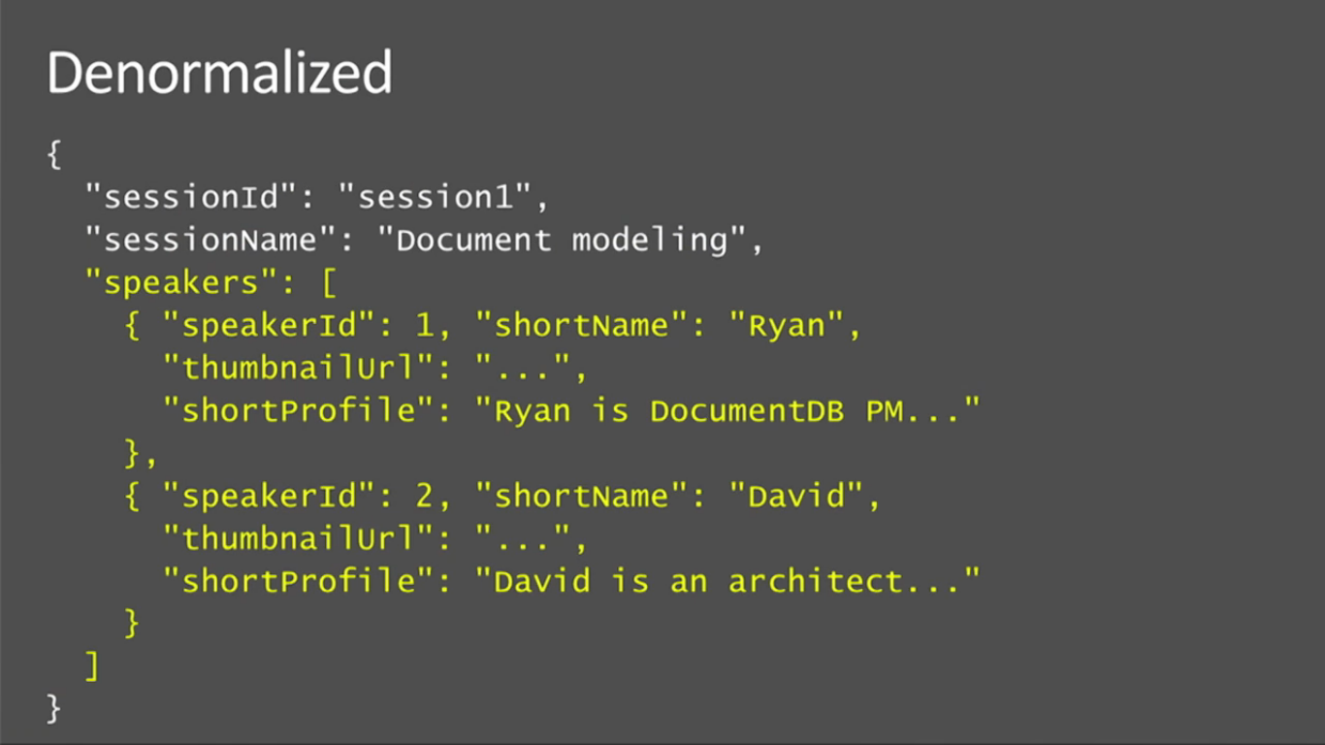

Session document contains the small information about the speaker and then when we click on the ‘more details’ about the speaker we can query the speaker document with the speaker id.

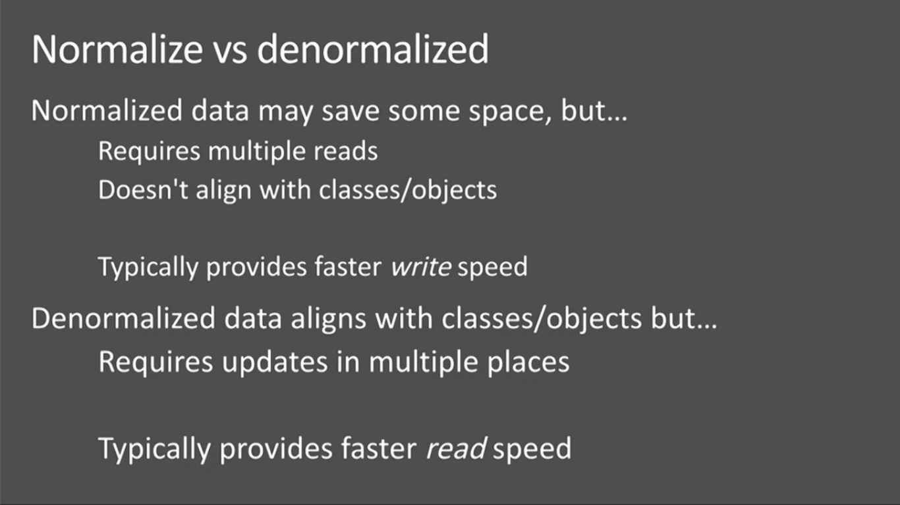

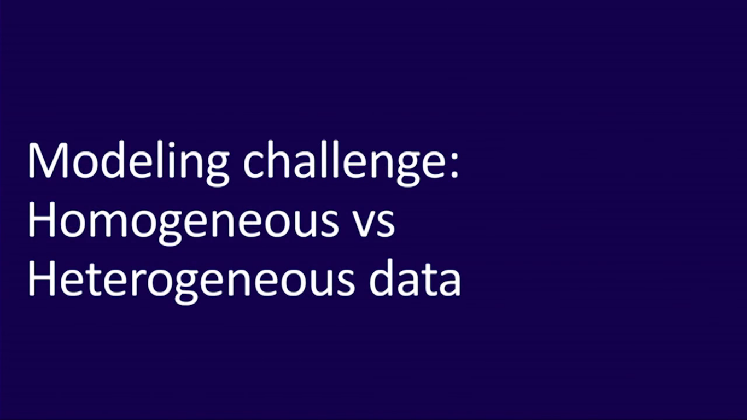

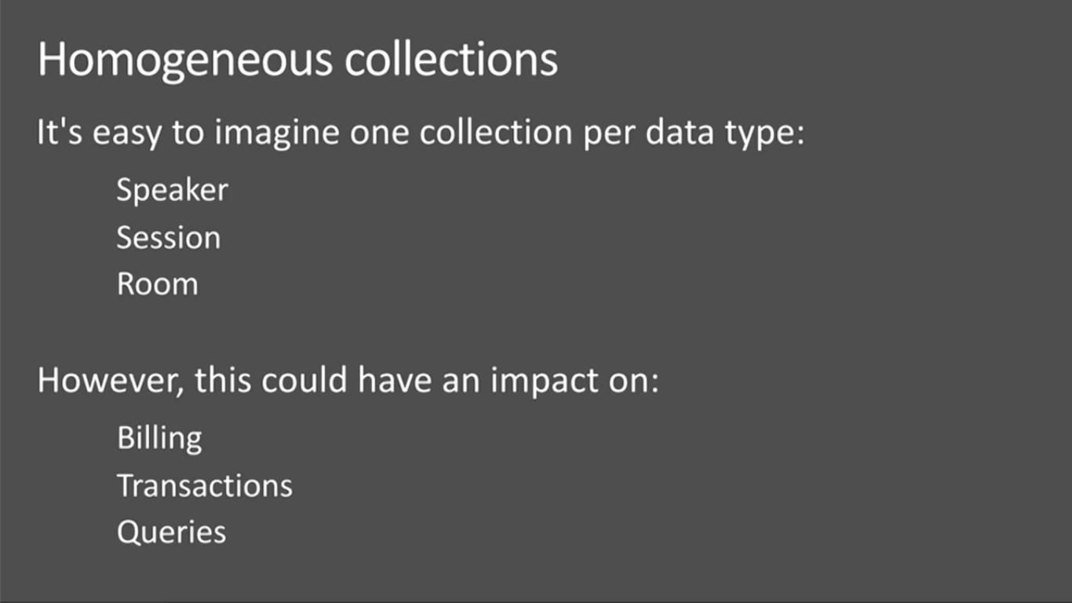

Tables or collections per speaker, session and Room.

Bill per collection, number of transactions, scope or queries bound by the given collection.

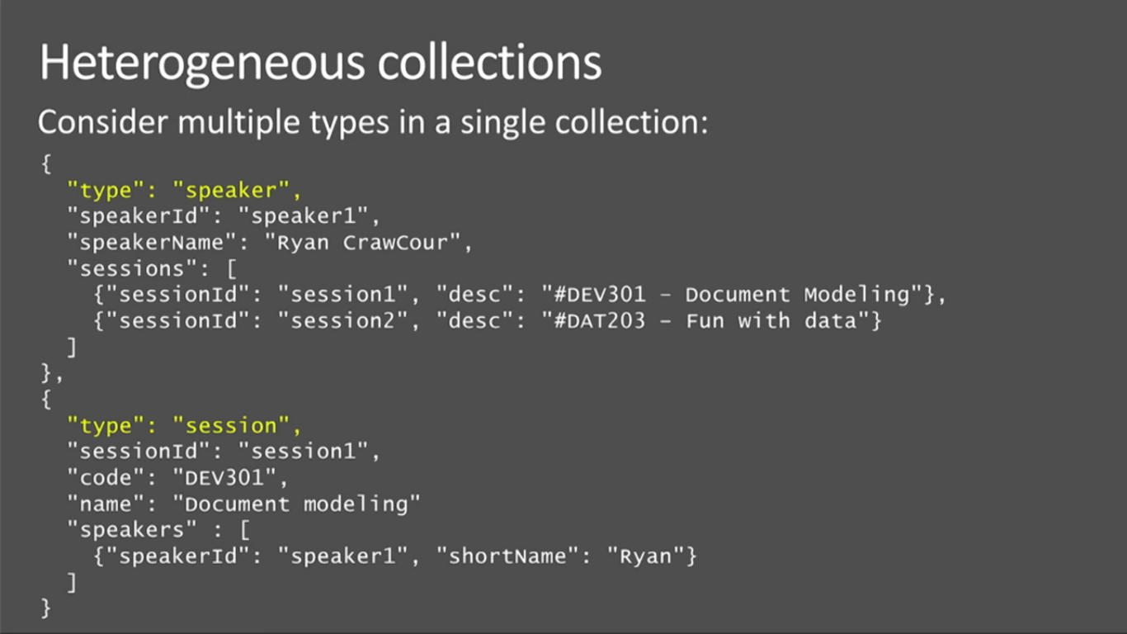

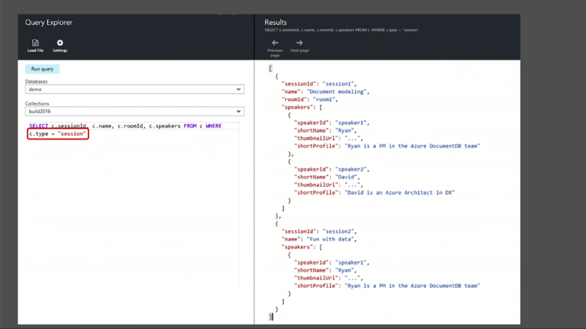

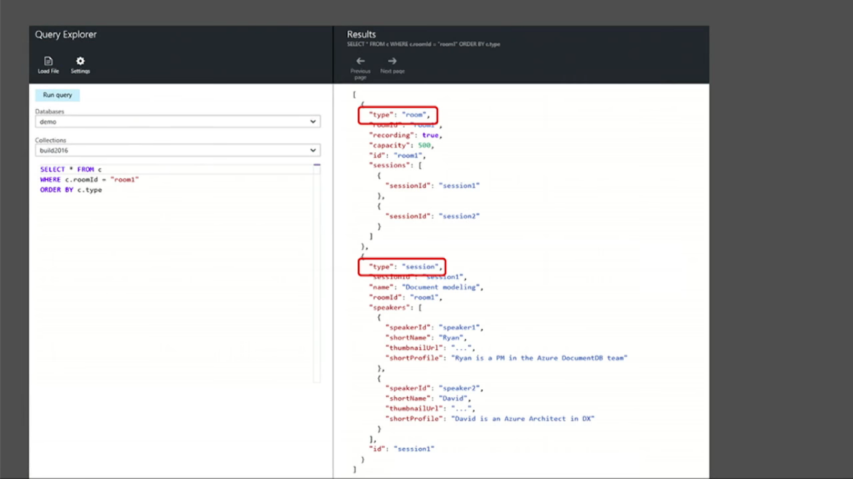

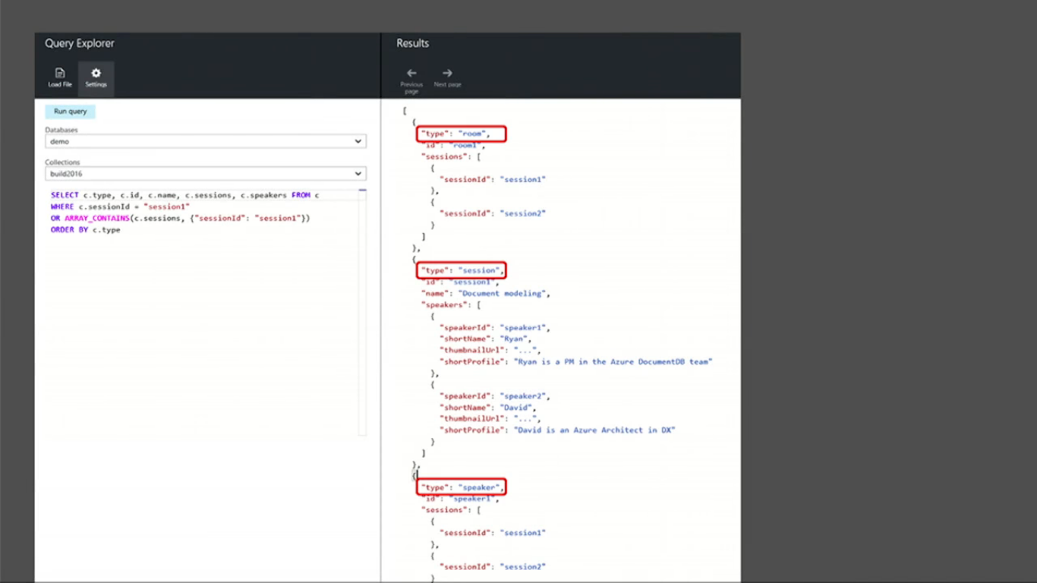

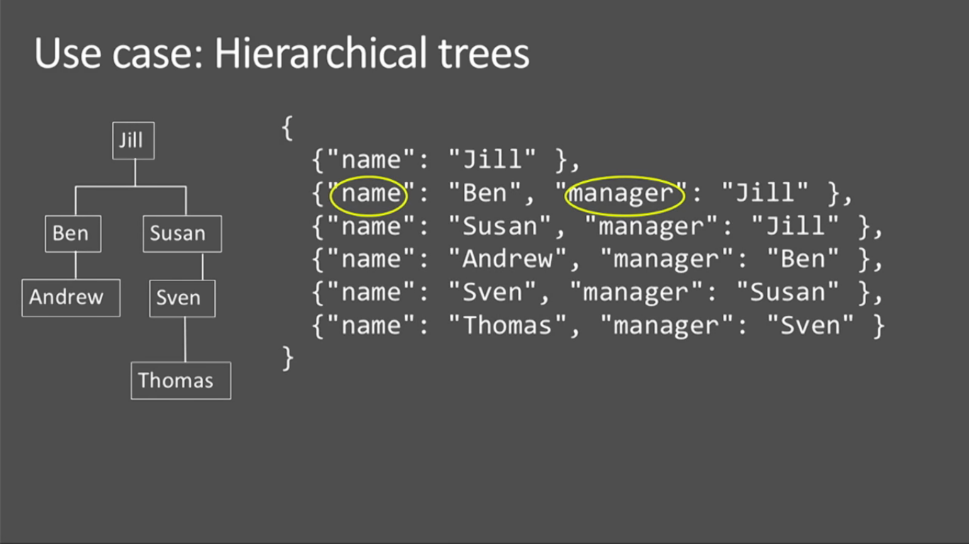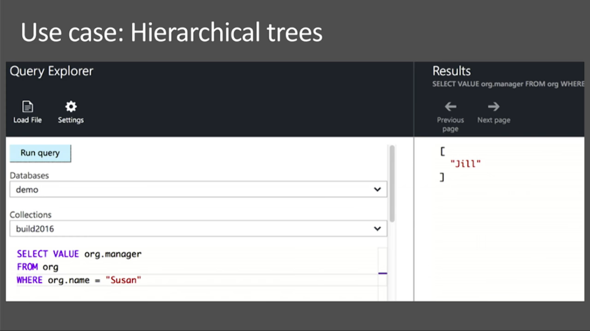

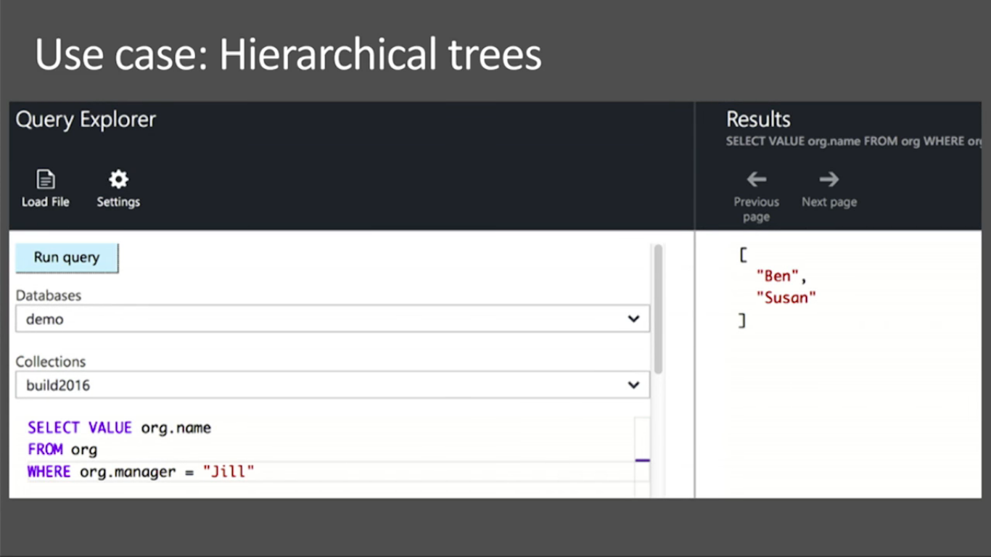

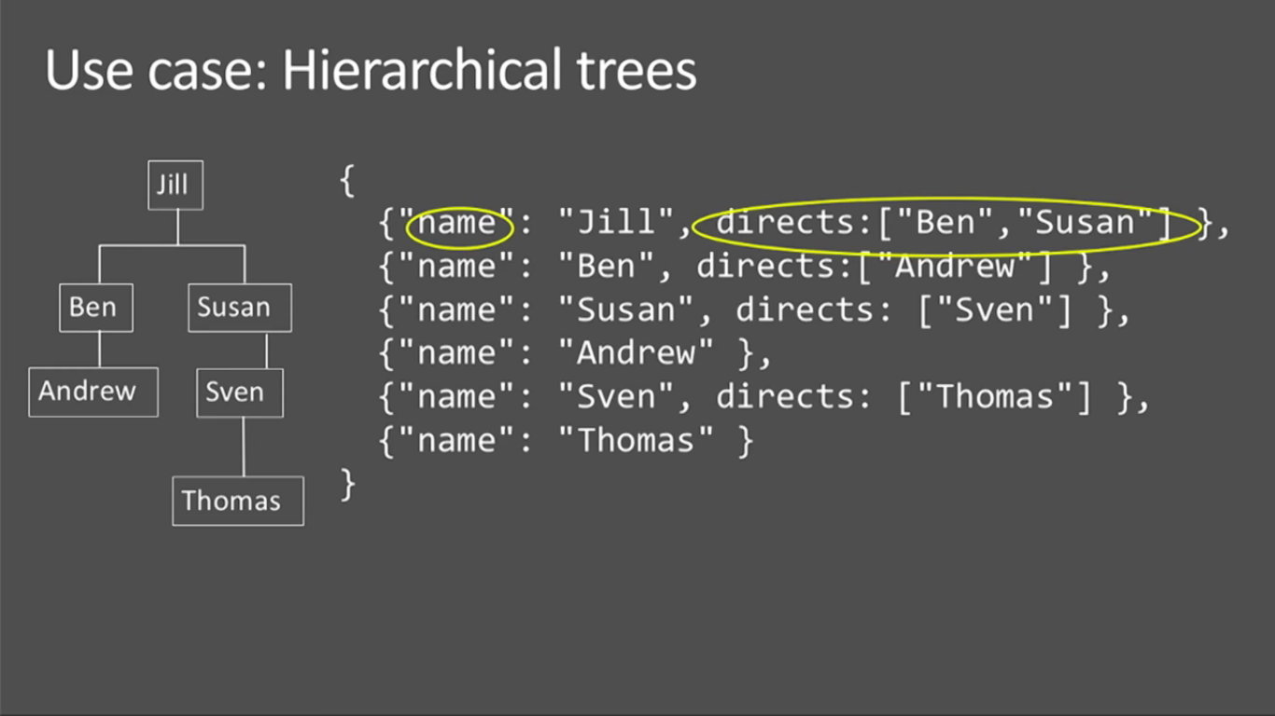

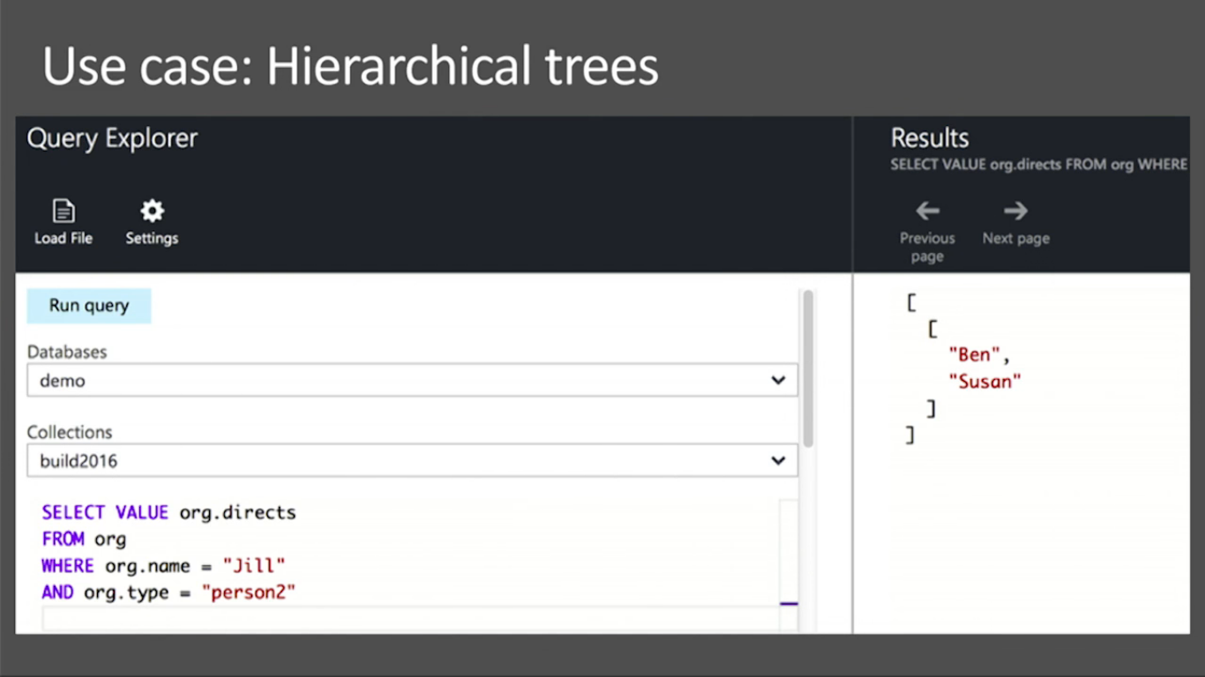

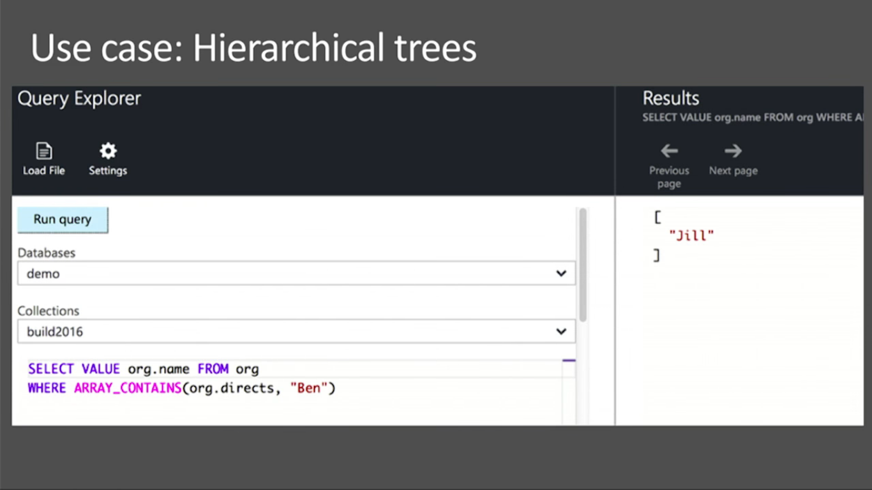

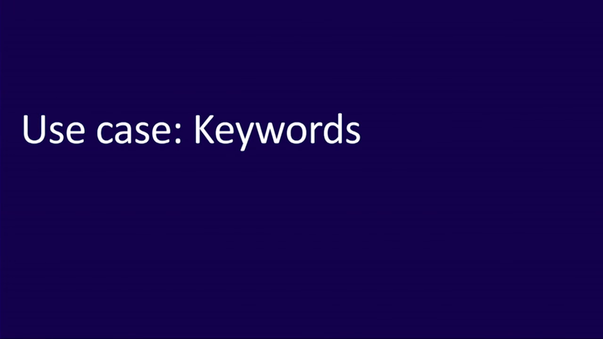

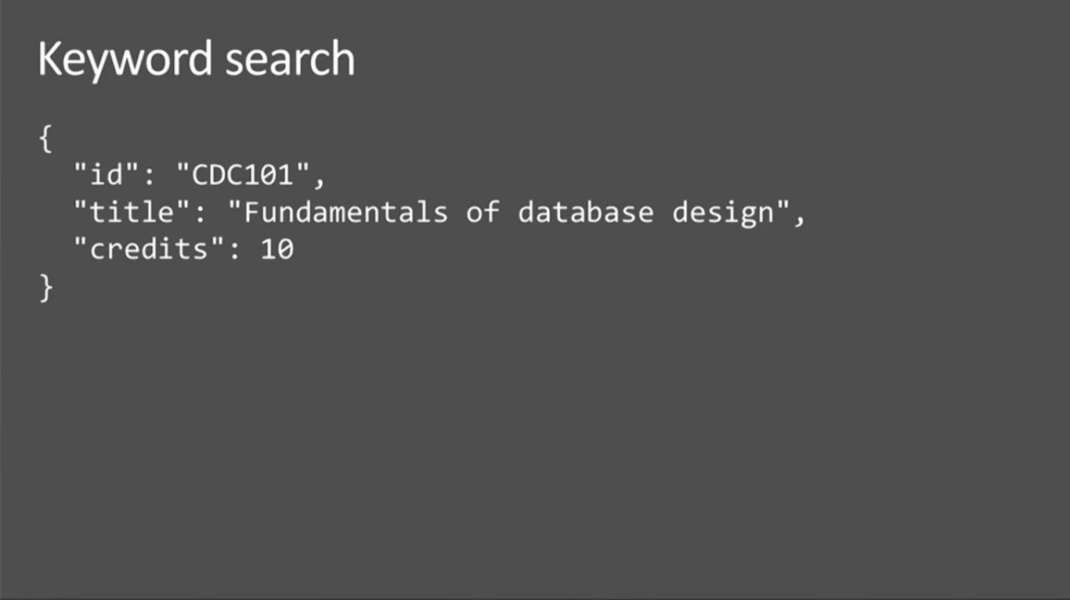

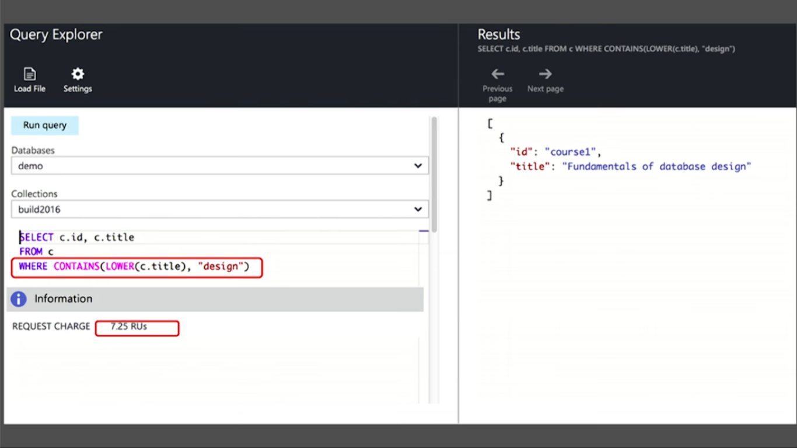

Same result with cheaper cost while we design with keywords. Actually lowercase conversion is costly.

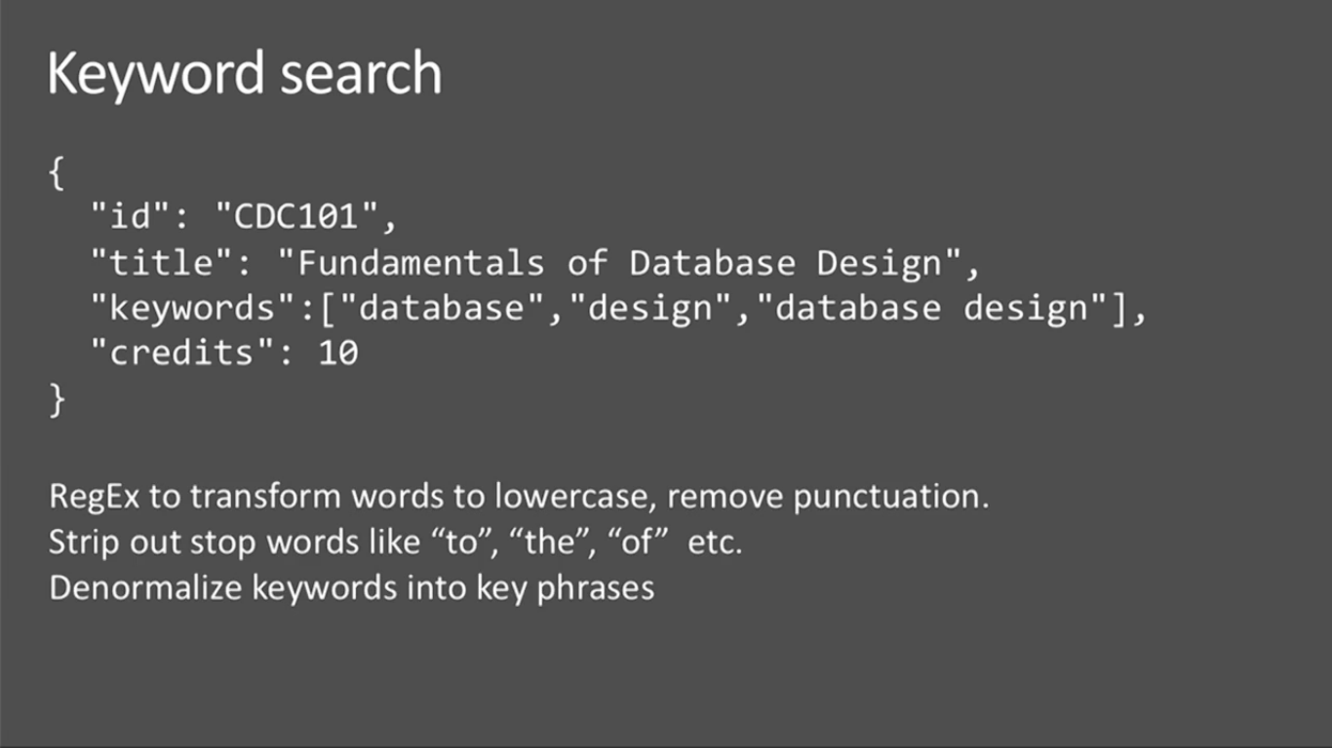

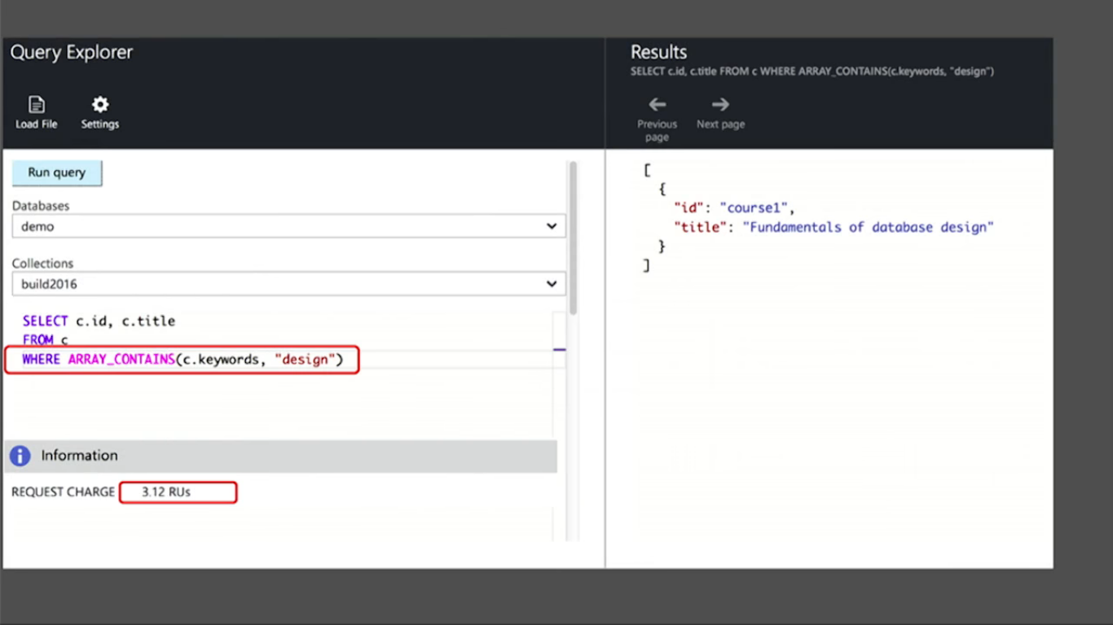

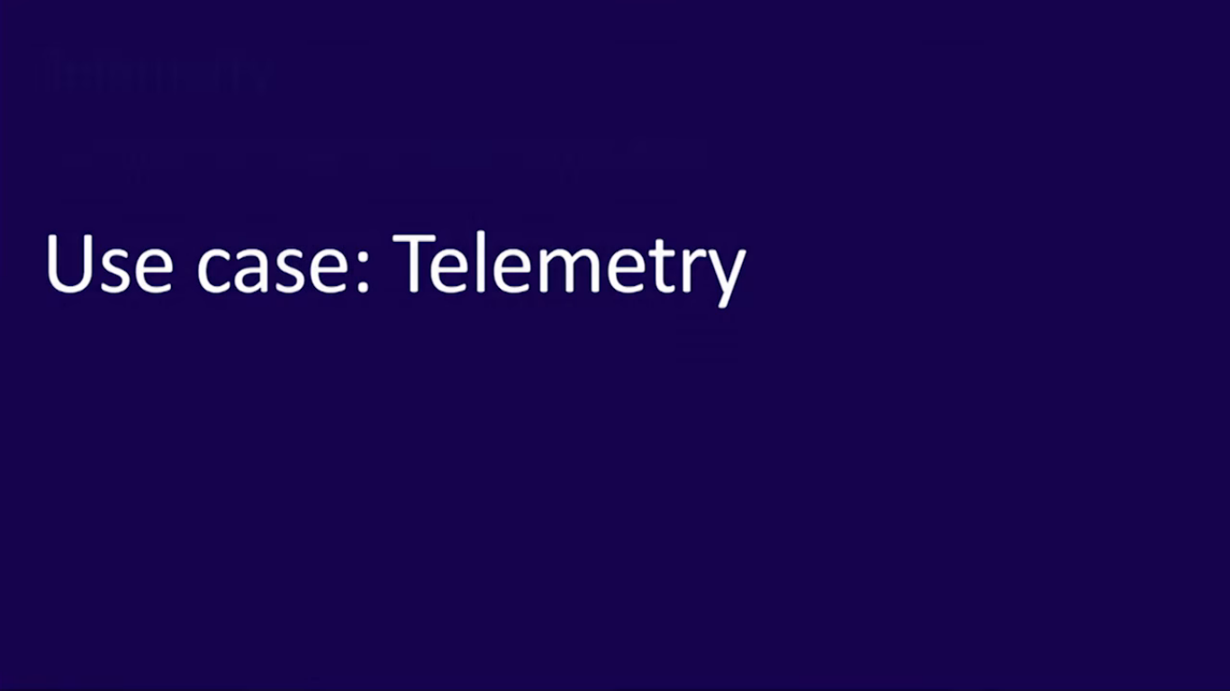

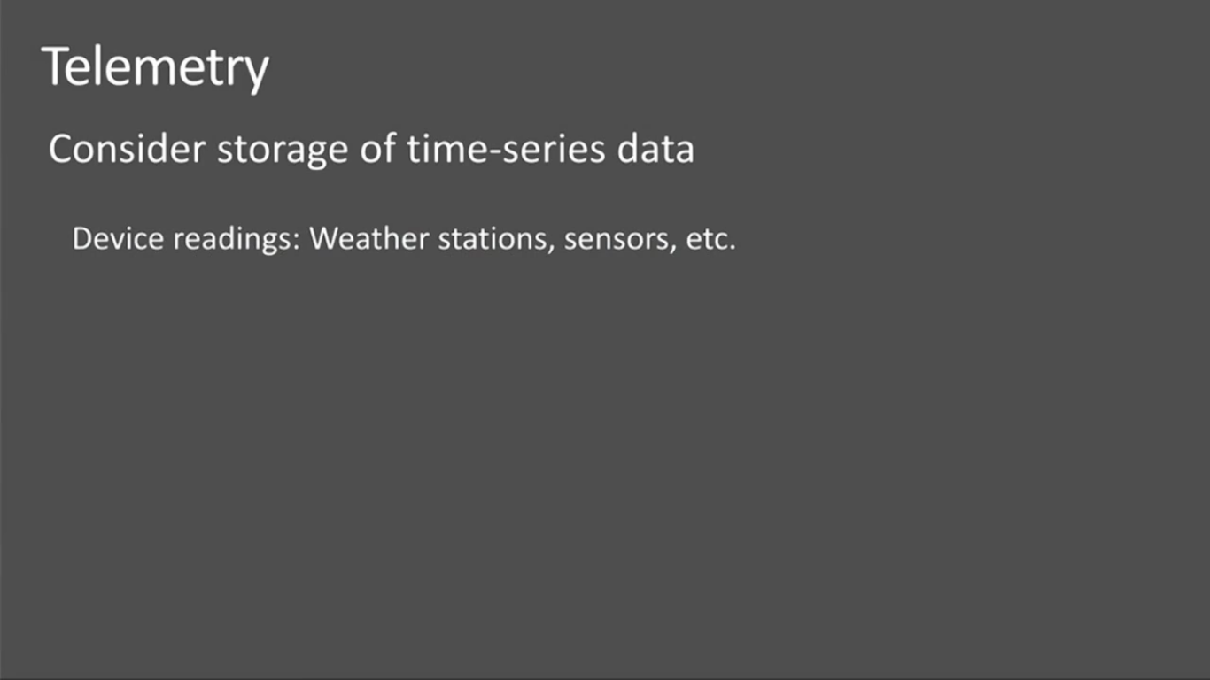

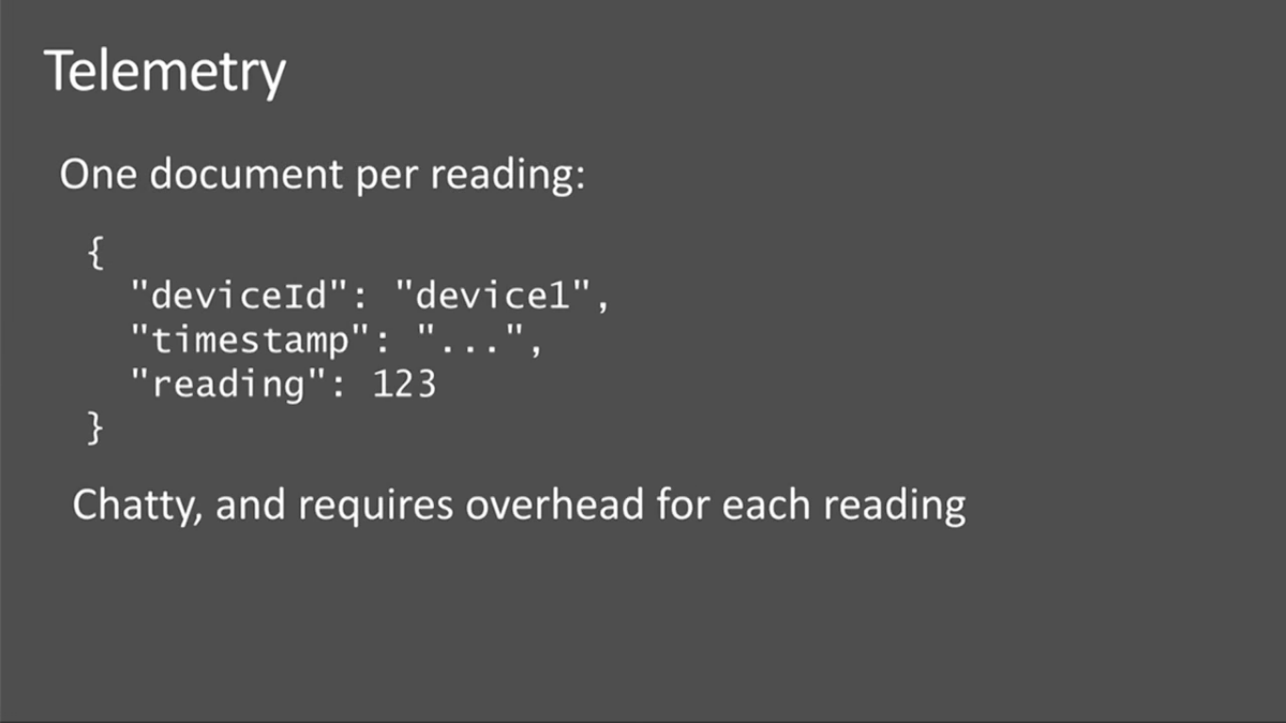

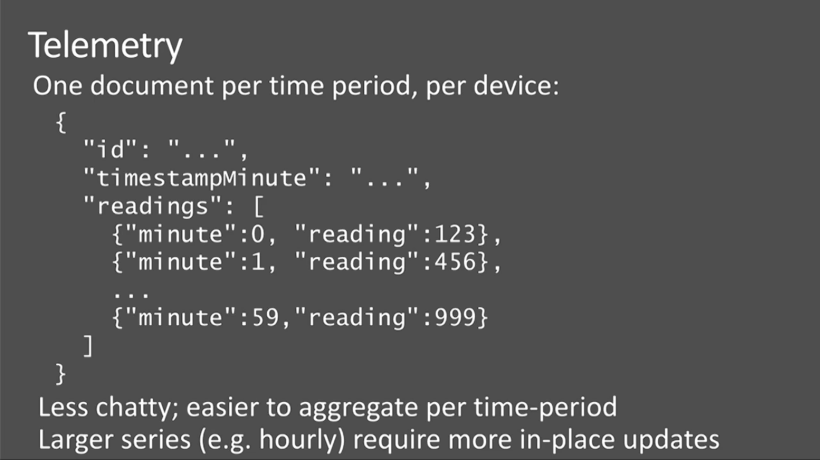

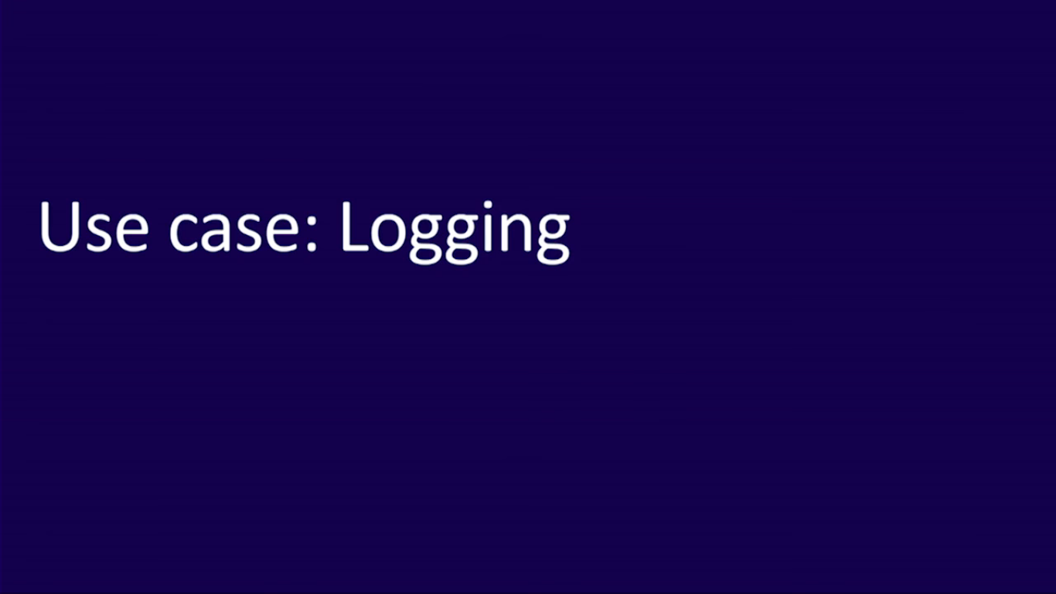

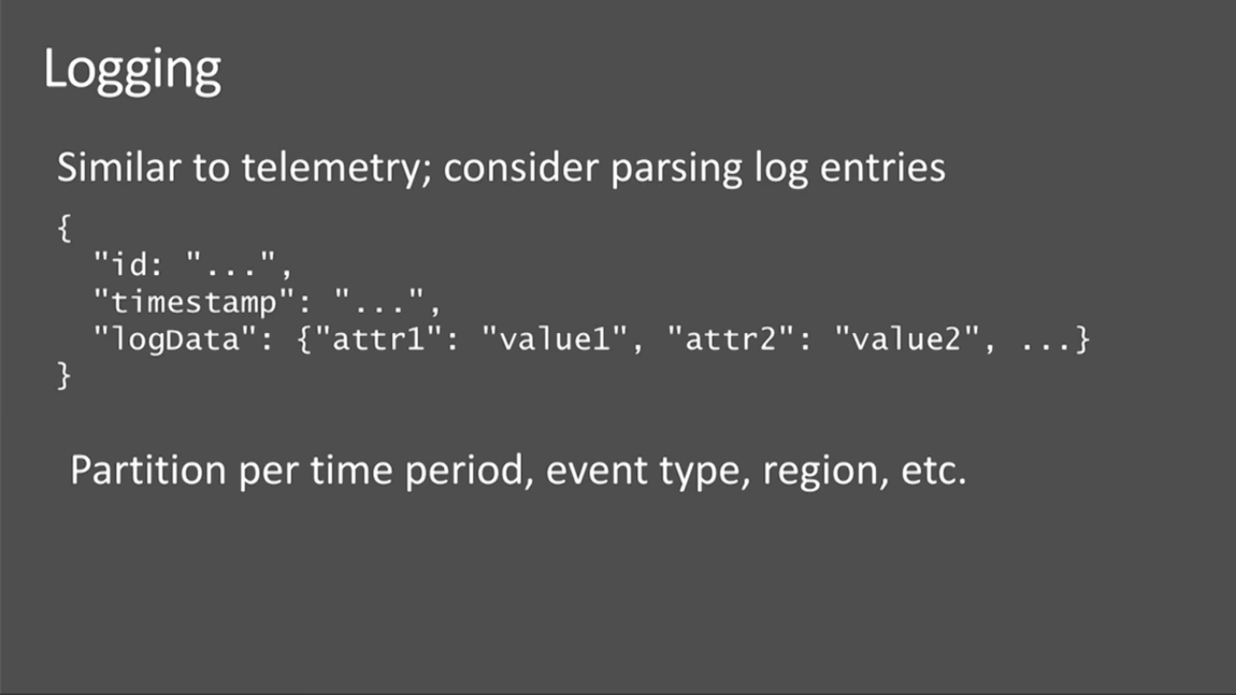

<https://www.youtube.com/watch?v=Ck70G6OuGT4&pbjreload=10>

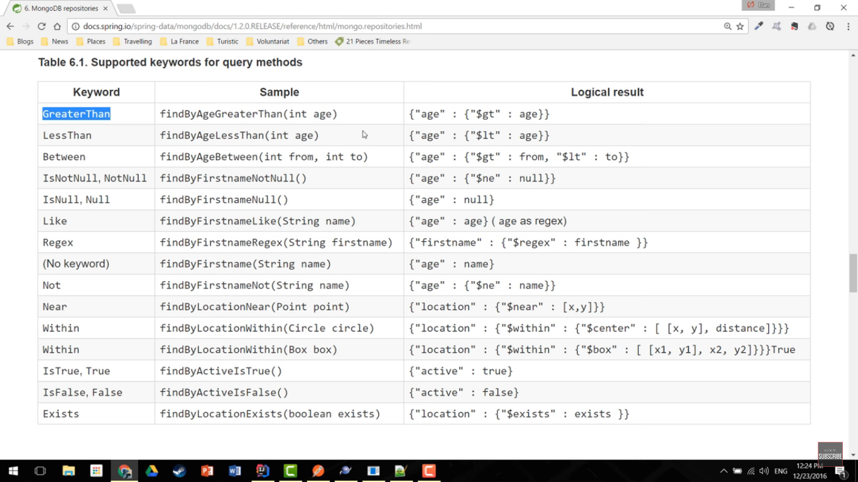

To-do: Mongo Query Language

| **Keyword** | **Sample** | **Logical result** |
| --- | --- | --- |
| After | findByBirthdateAfter(Date date) | {"birthdate" : {"$gt" : date}} |
| GreaterThan | findByAgeGreaterThan(int age) | {"age" : {"$gt" : age}} |
| GreaterThanEqual | findByAgeGreaterThanEqual(int age) | {"age" : {"$gte" : age}} |
| Before | findByBirthdateBefore(Date date) | {"birthdate" : {"$lt" : date}} |
| LessThan | findByAgeLessThan(int age) | {"age" : {"$lt" : age}} |
| LessThanEqual | findByAgeLessThanEqual(int age) | {"age" : {"$lte" : age}} |
| Between | findByAgeBetween(int from, int to) | {"age" : {"$gt" : from, "$lt" : to}} |
| In | findByAgeIn(Collection ages) | {"age" : {"$in" : [ages…​]}} |
| NotIn | findByAgeNotIn(Collection ages) | {"age" : {"$nin" : [ages…​]}} |
| IsNotNull, NotNull | findByFirstnameNotNull() | {"firstname" : {"$ne" : null}} |
| IsNull, Null | findByFirstnameNull() | {"firstname" : null} |
| Like, StartingWith, EndingWith | findByFirstnameLike(String name) | {"firstname" : name} (name as regex) |
| NotLike, IsNotLike | findByFirstnameNotLike(String name) | {"firstname" : { "$not" : name }} (name as regex) |
| Containing on String | findByFirstnameContaining(String name) | {"firstname" : name} (name as regex) |
| NotContaining on String | findByFirstnameNotContaining(String name) | {"firstname" : { "$not" : name}} (name as regex) |
| Containing on Collection | findByAddressesContaining(Address address) | {"addresses" : { "$in" : address}} |
| NotContaining on Collection | findByAddressesNotContaining(Address address) | {"addresses" : { "$not" : { "$in" : address}}} |
| Regex | findByFirstnameRegex(String firstname) | {"firstname" : {"$regex" : firstname }} |
| (No keyword) | findByFirstname(String name) | {"firstname" : name} |
| Not | findByFirstnameNot(String name) | {"firstname" : {"$ne" : name}} |
| Near | findByLocationNear(Point point) | {"location" : {"$near" : [x,y]}} |
| Near | findByLocationNear(Point point, Distance max) | {"location" : {"$near" : [x,y], "$maxDistance" : max}} |
| Near | findByLocationNear(Point point, Distance min, Distance max) | {"location" : {"$near" : [x,y], "$minDistance" : min, "$maxDistance" : max}} |
| Within | findByLocationWithin(Circle circle) | {"location" : {"$geoWithin" : {"$center" : [ [x, y], distance]}}} |
| Within | findByLocationWithin(Box box) | {"location" : {"$geoWithin" : {"$box" : [ [x1, y1], x2, y2]}}} |
| IsTrue, True | findByActiveIsTrue() | {"active" : true} |
| IsFalse, False | findByActiveIsFalse() | {"active" : false} |
| Exists | findByLocationExists(boolean exists) | {"location" : {"$exists" : exists }} |

# 2 ways of querying the Mongo DB from Spring

1. Mongo Template
2. Mongo Repositories

Mongo Repositories interface is also using underneath Mongo template to do the CRUD operation.

<https://www.youtube.com/watch?v=PIWVFUtBV1Q&pbjreload=10>

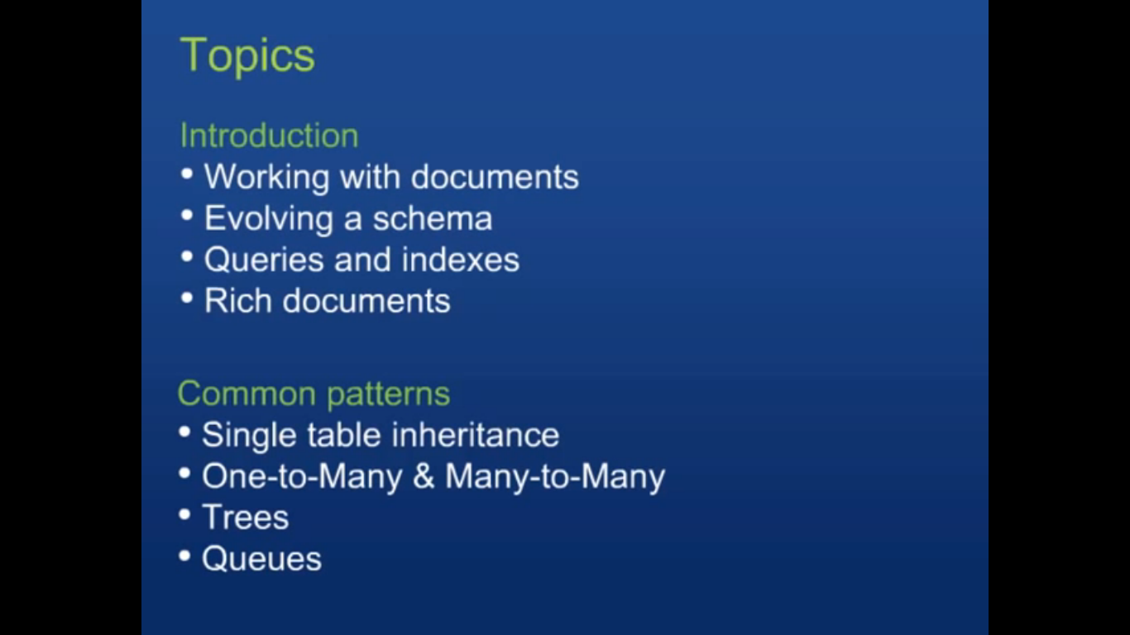

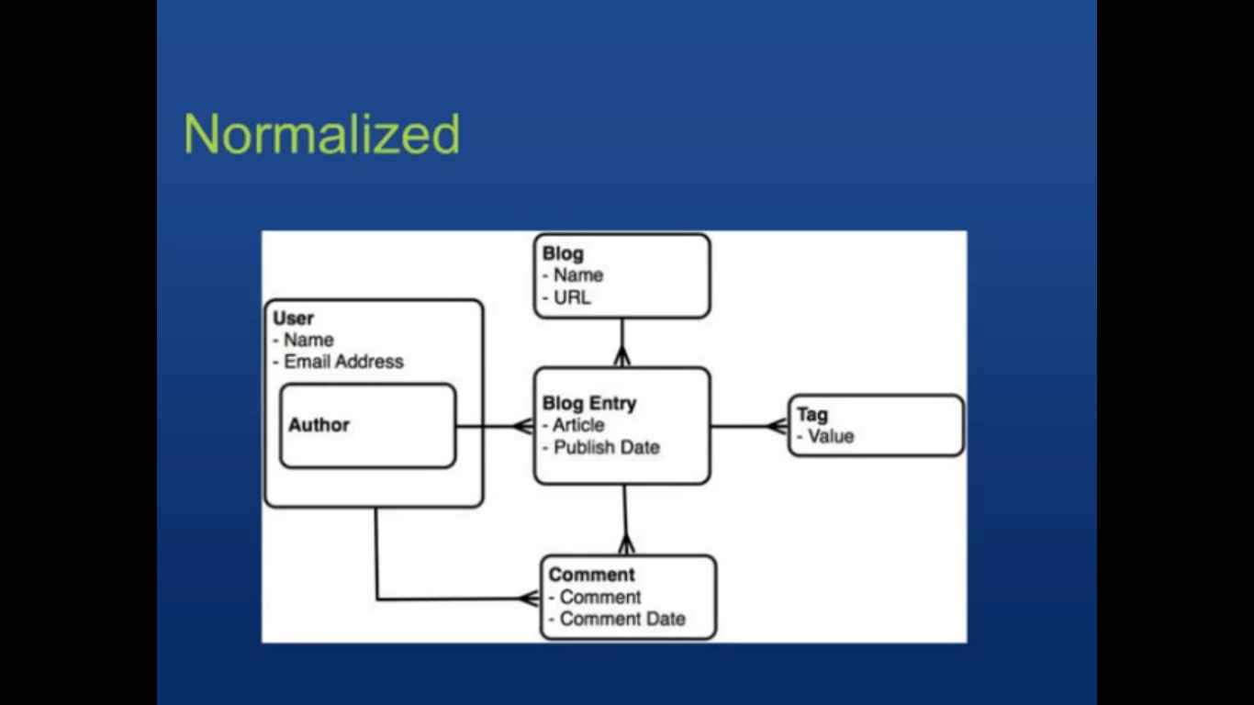

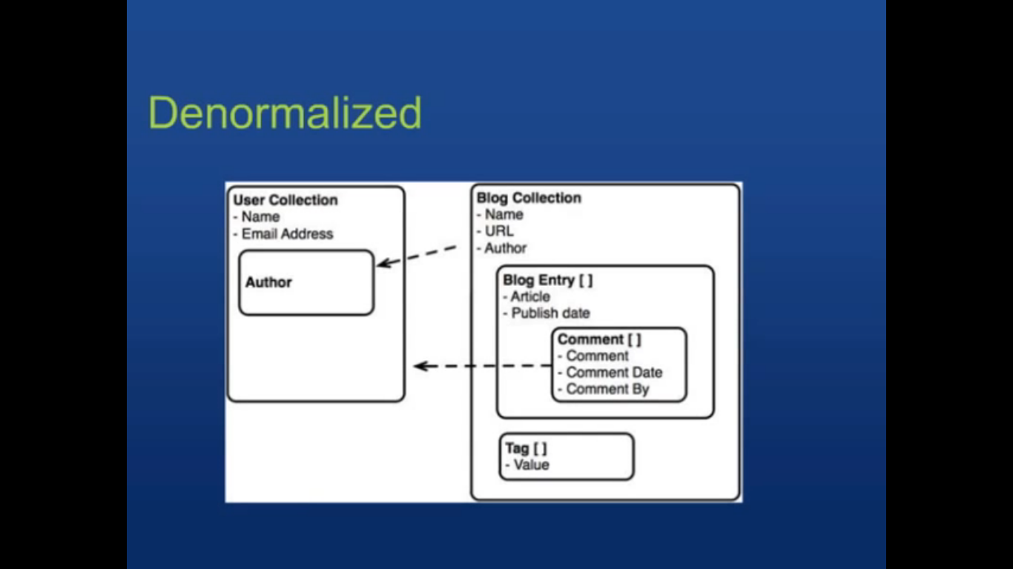

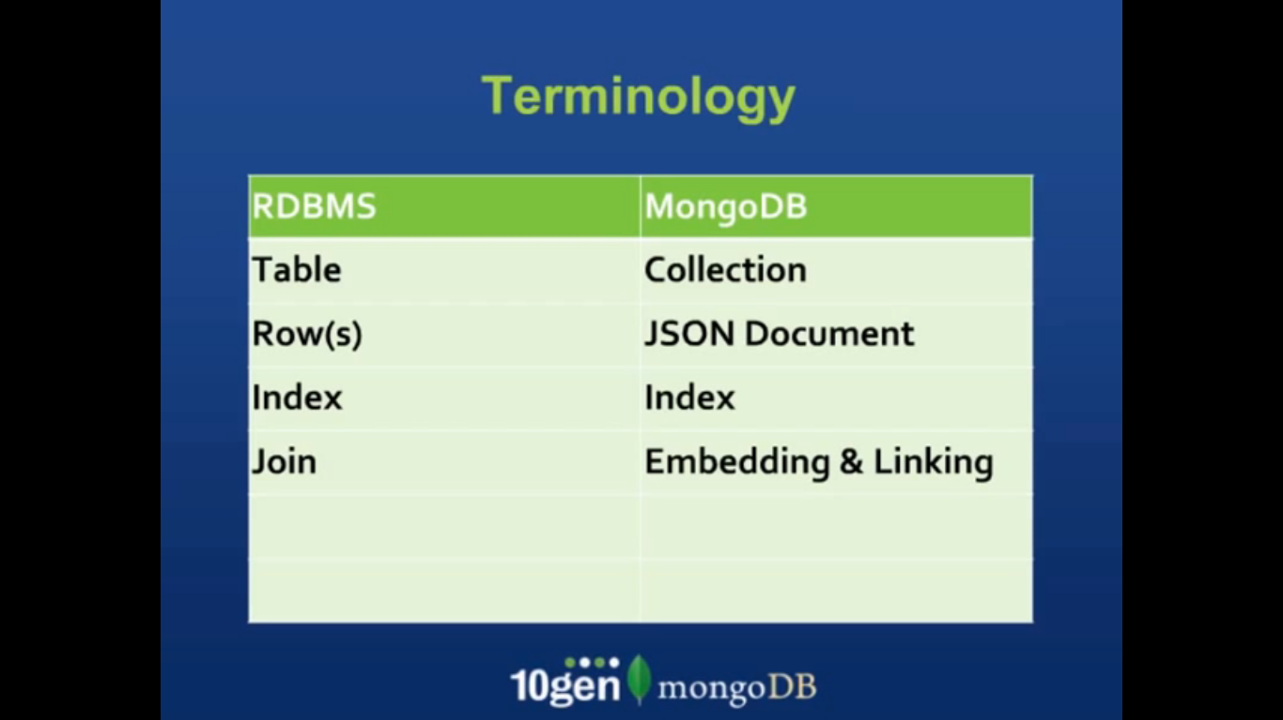

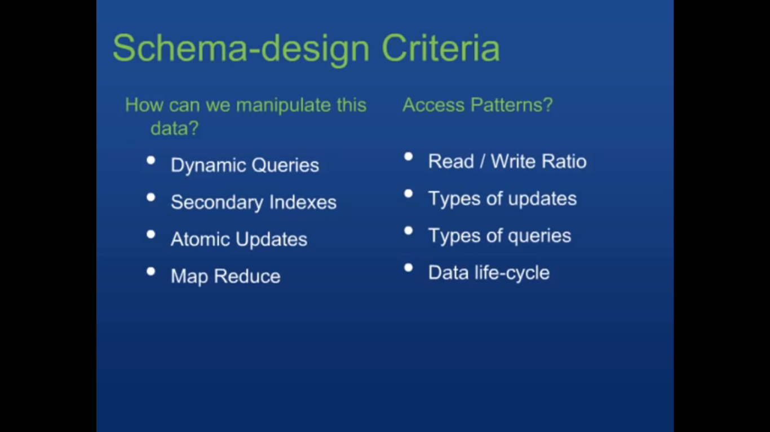

We can send the java scripts map reduce function to Mongo directly. It will take care.

Joins – scalability is difficult. While talking to arbitrary (Multiple) nodes during join, will make the things slow.

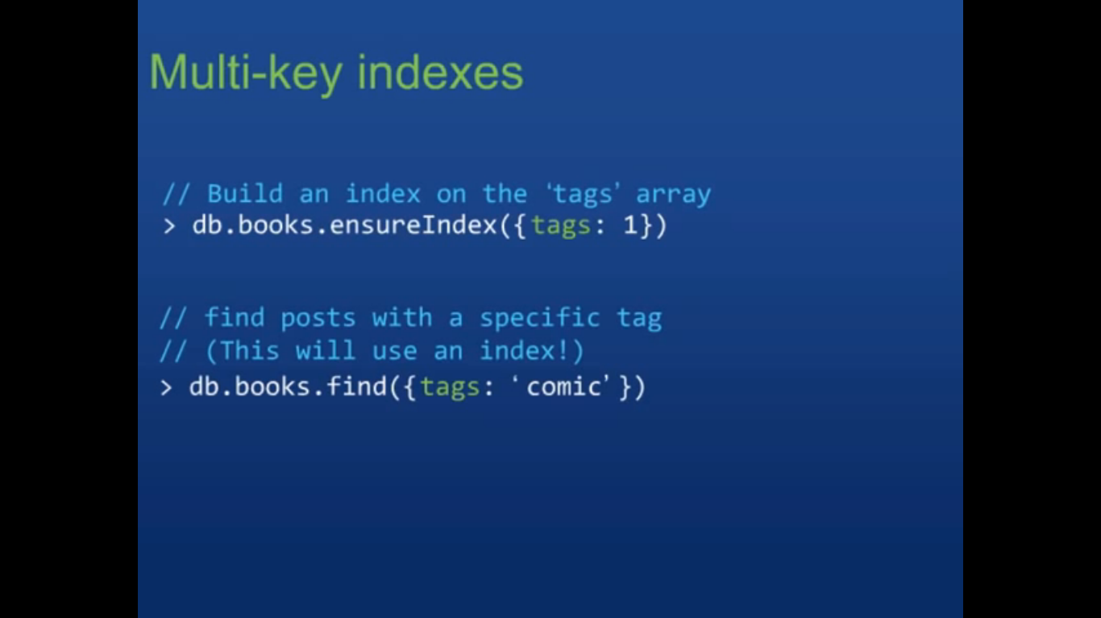

Tags is array. Need not do any joins.

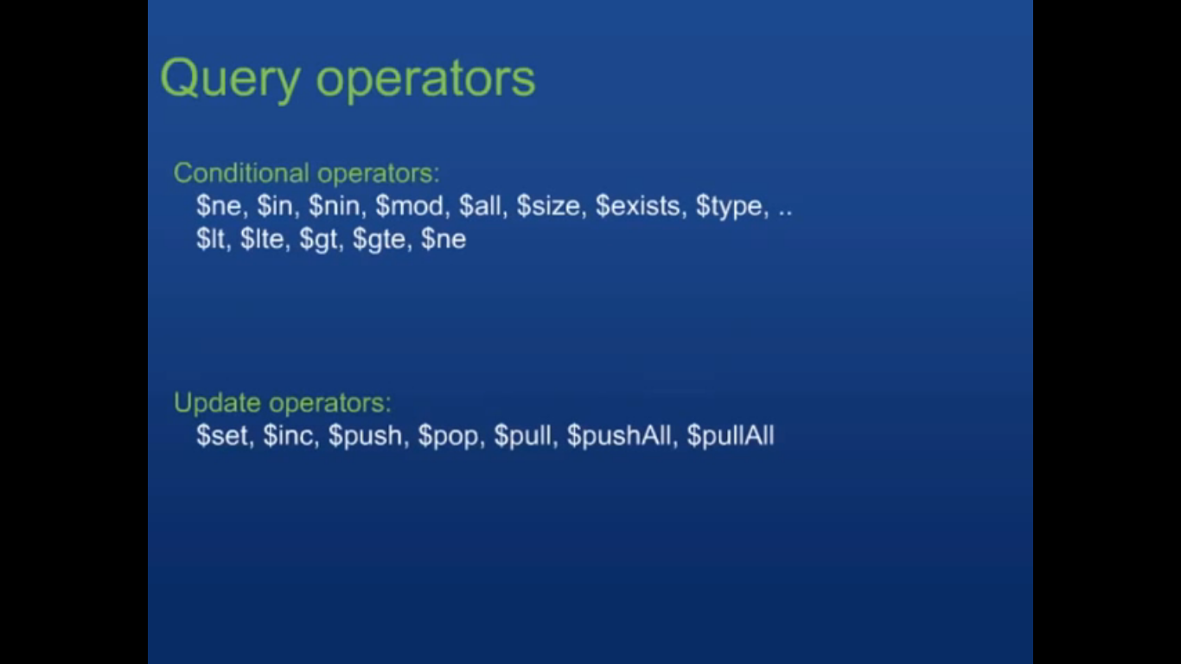

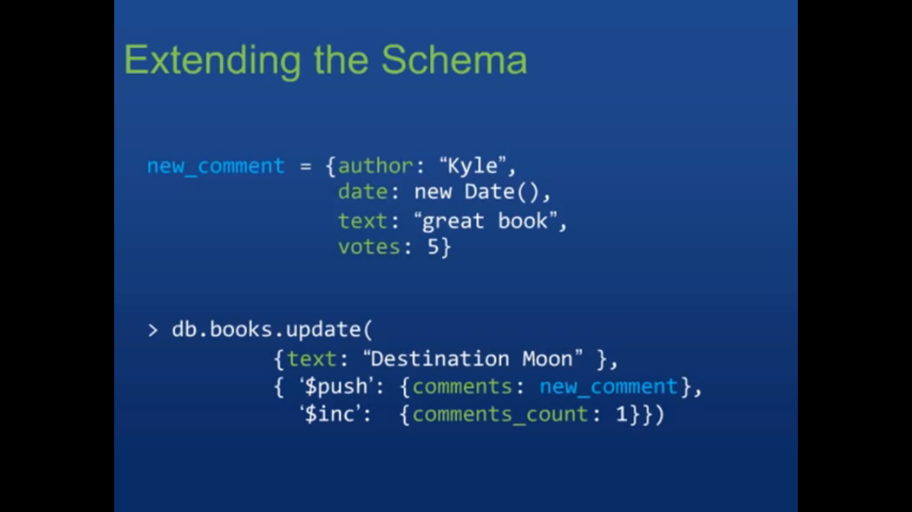

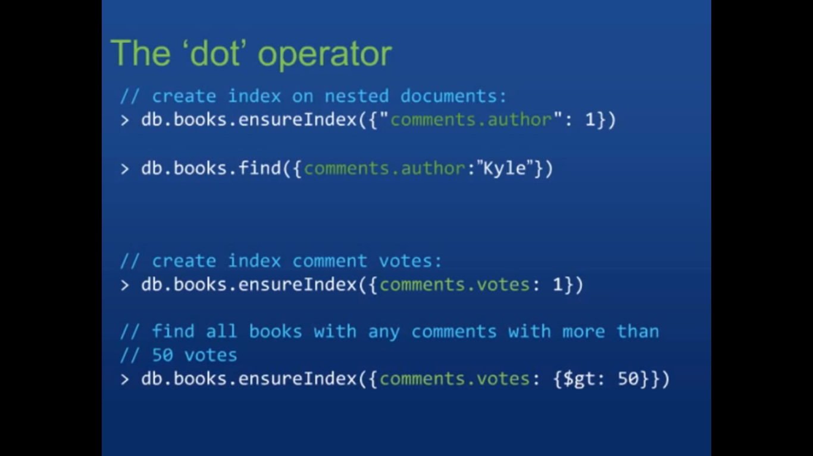

Example – Order details:

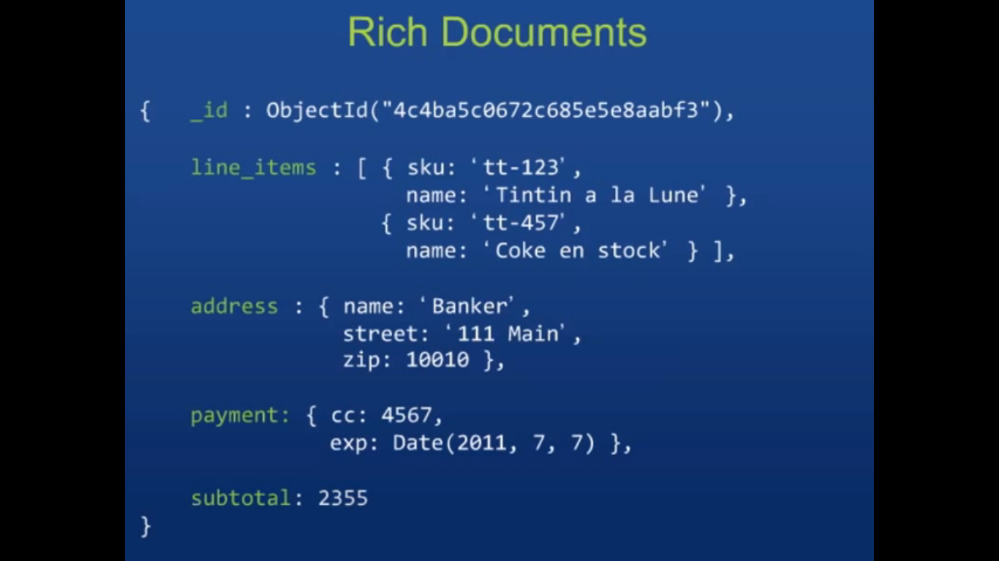

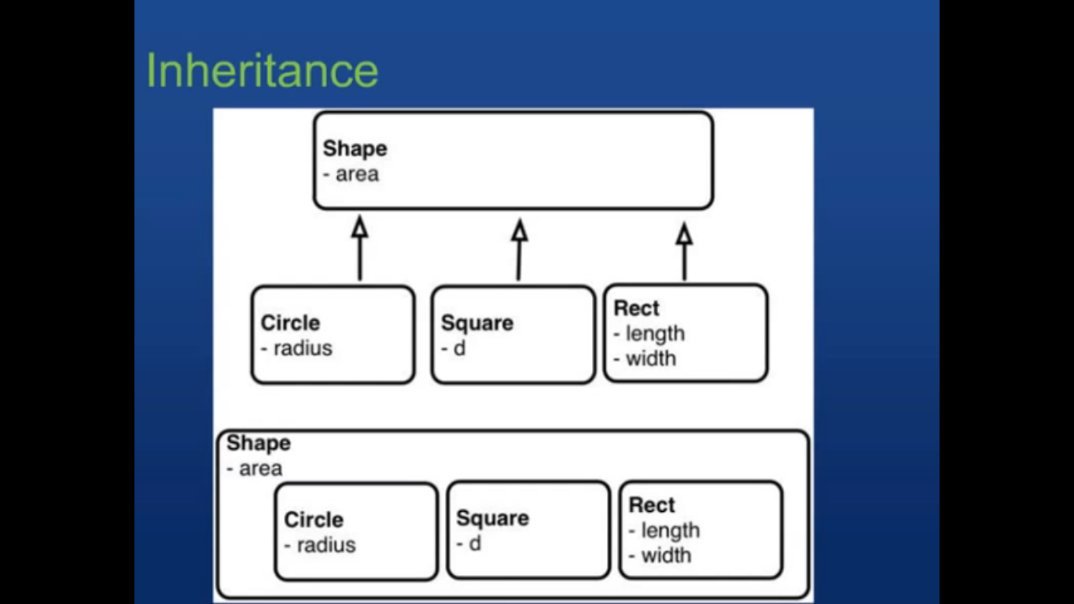

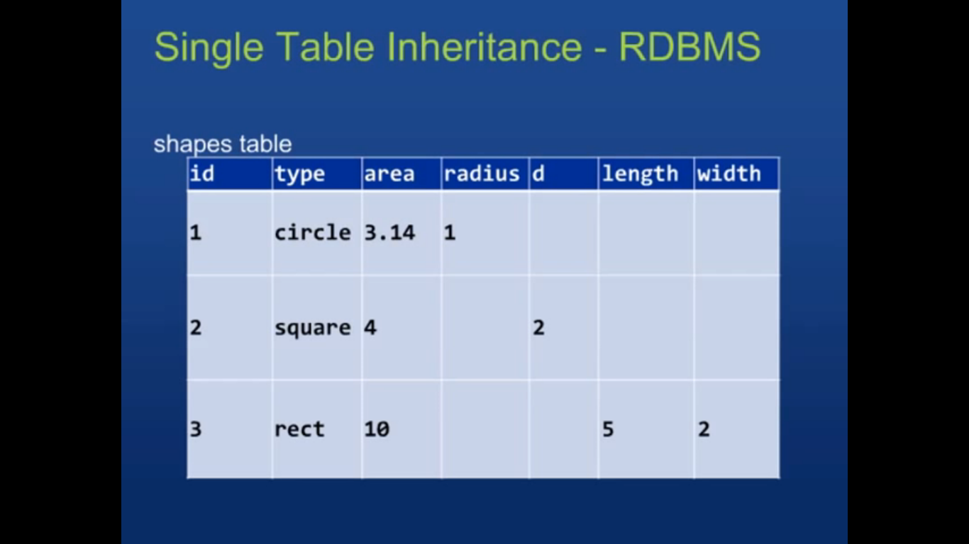

Query planner will not consider the rows which doesn’t have relevant query column.

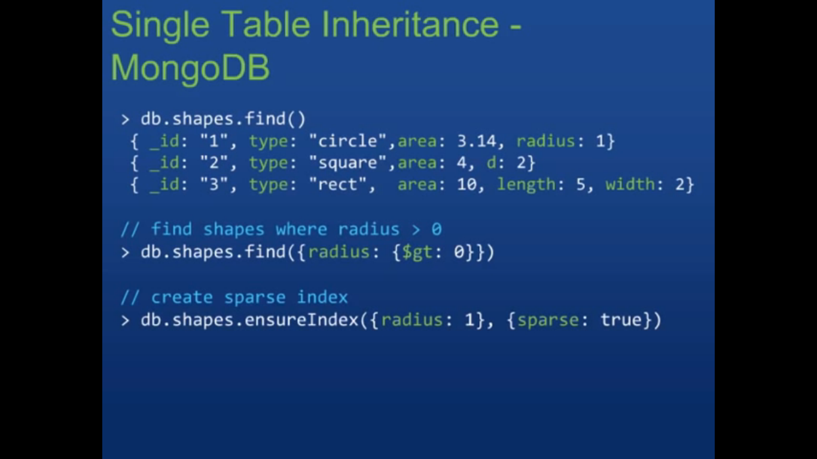

Sparse index helps to create index only for the attributes available in the documents. Rest of the documents will not have index for the specified attributes.

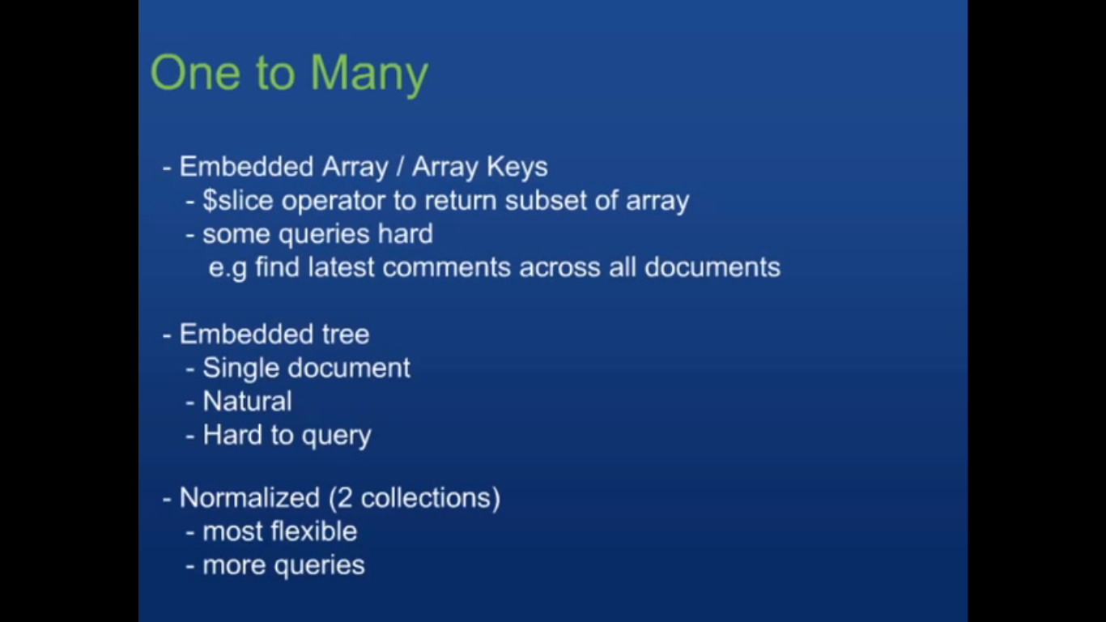

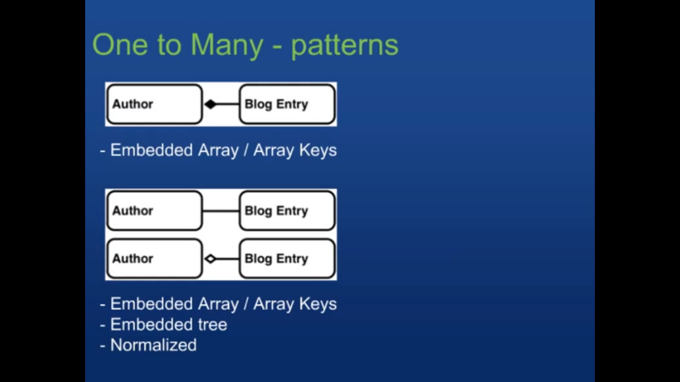

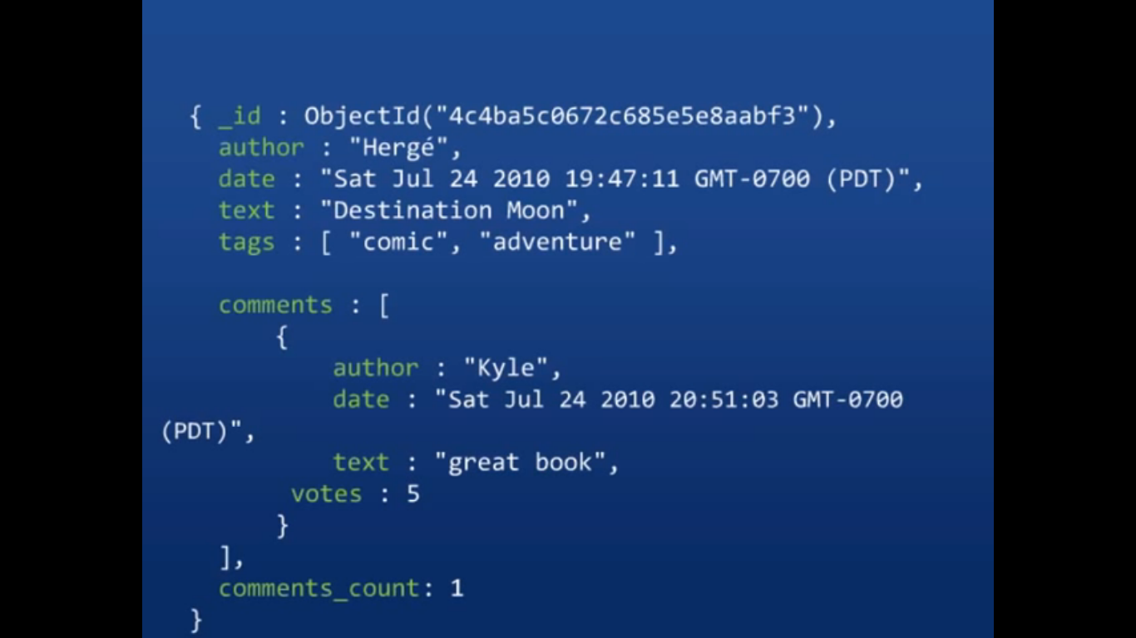

Normalized:

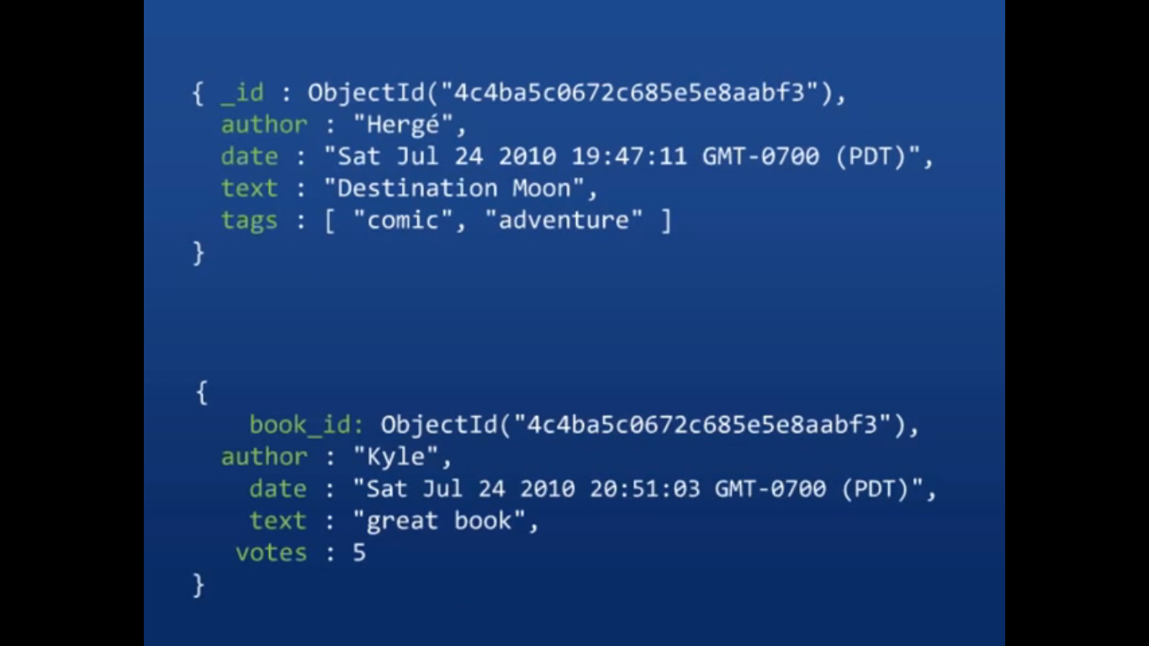

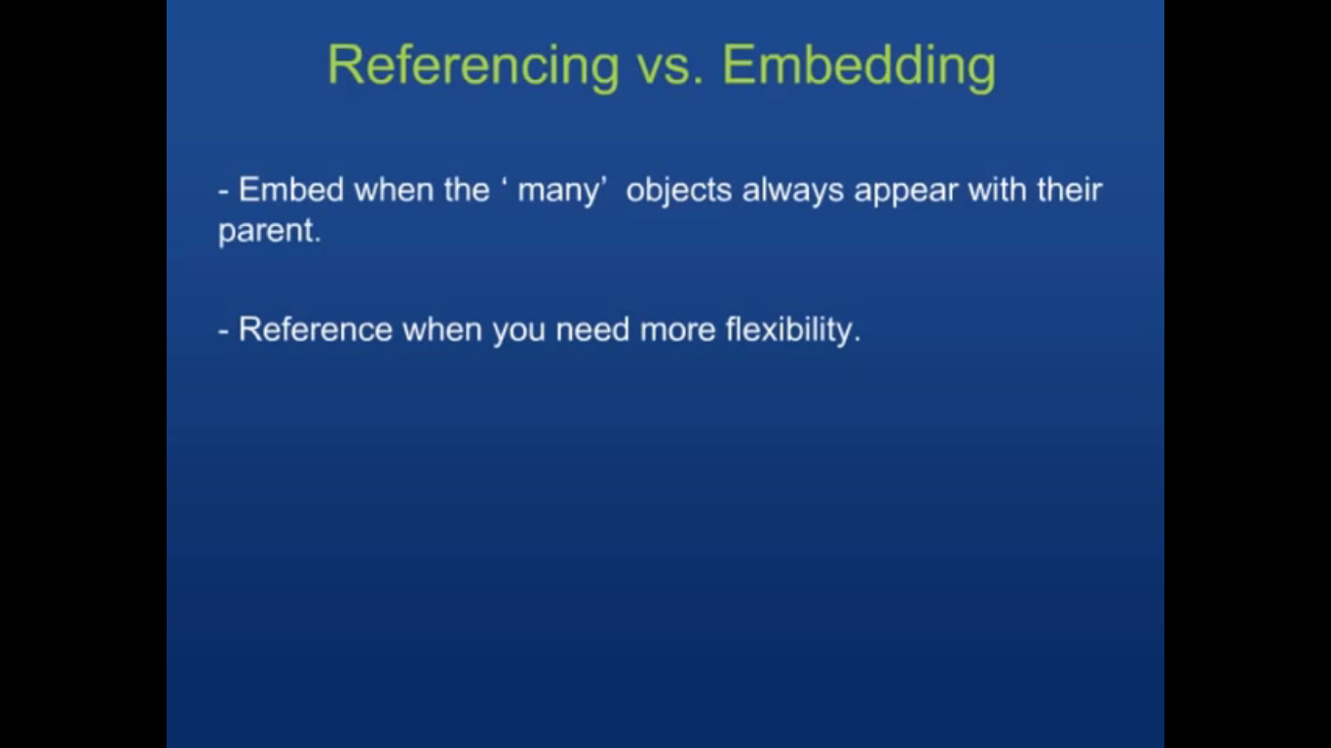

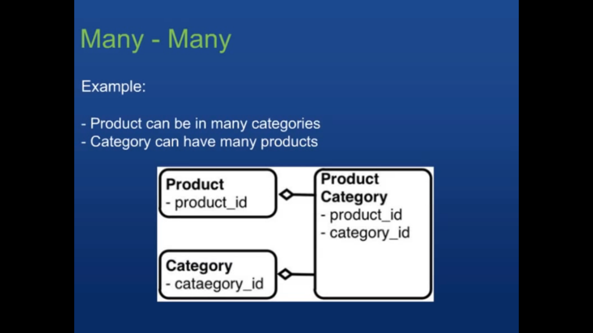

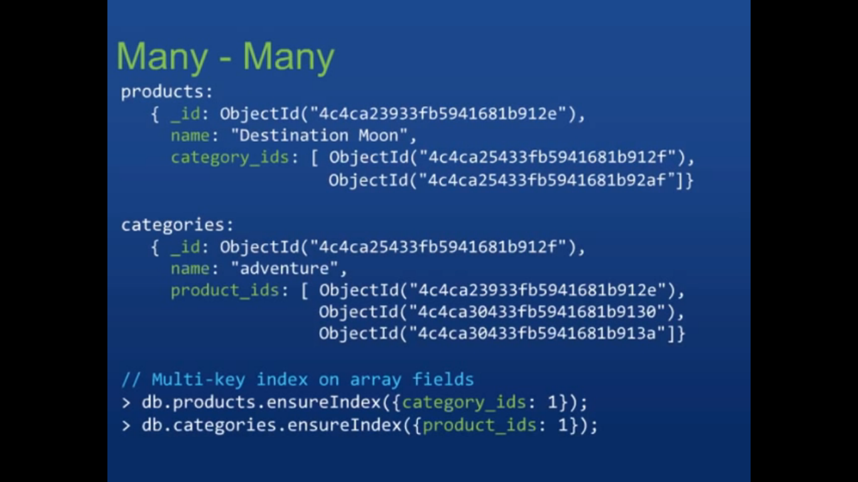

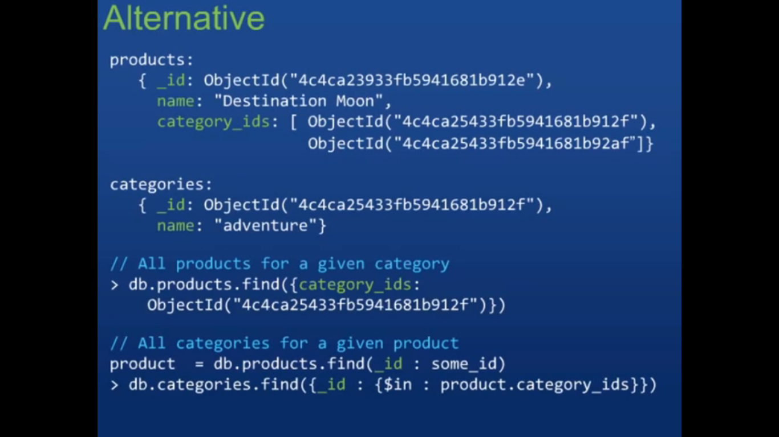

Add index to the category_ids to make the query fast.

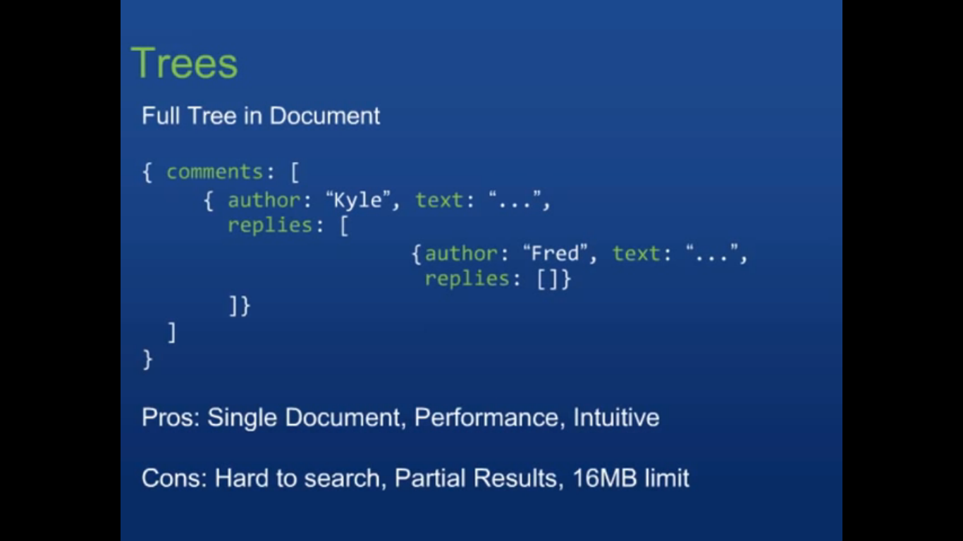

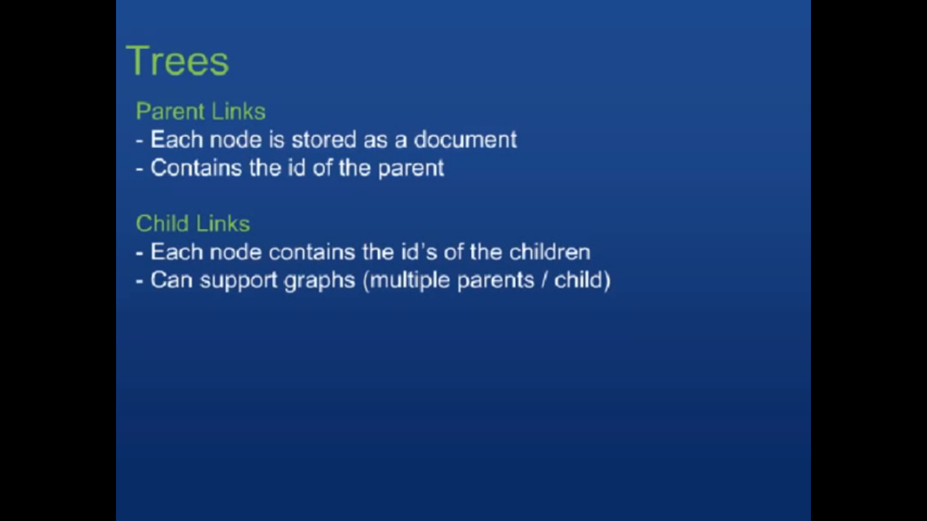

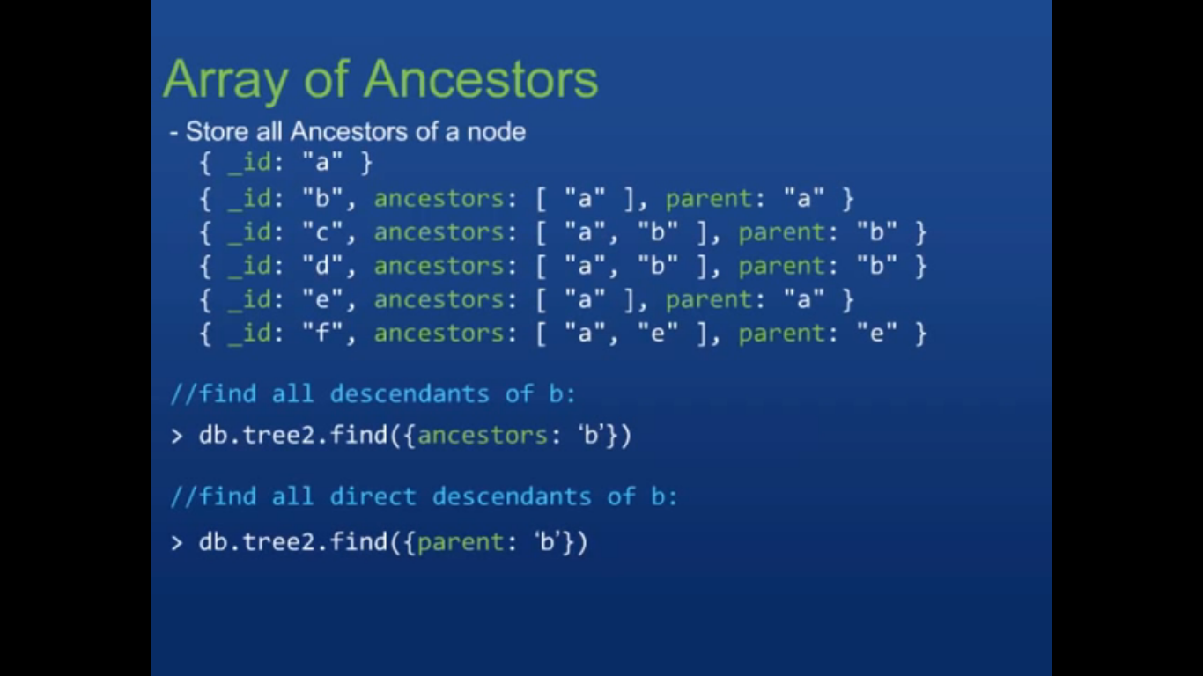

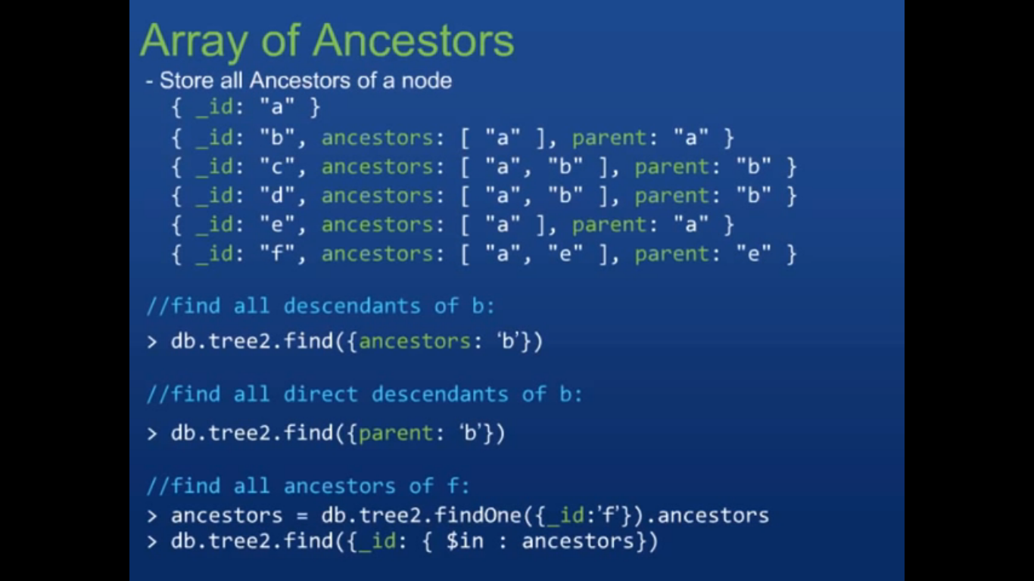

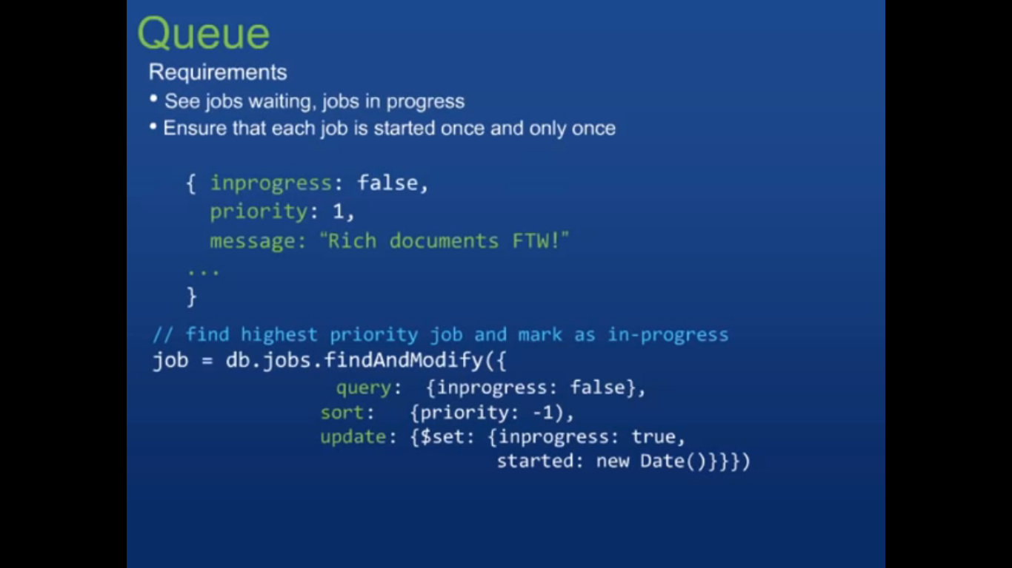

DB Wrap can be used instead of Object ID – DB Wrap is referring to the other collection’s object id. DB Wrap is just a convention which contains the collection name and object ID. Really not much worthy. - Not clear.